Huawei Storage Certification Training

HCIA-Storage V5.0 Lab Environment

Setup Guide   
(Physical Environment Version)



Huawei Technologies Co., Ltd.

|  |
| --- |
| Copyright © Huawei Technologies Co., Ltd. 2022. All rights reserved.  No part of this document may be reproduced or transmitted in any form or by any means without prior written consent of Huawei Technologies Co., Ltd.  Trademarks and Permissions  C:\Users\jwx341670\AppData\Local\Microsoft\Windows\INetCache\Content.Word\HW_POS_RBG_Vertical-150ppi.png and other Huawei trademarks are trademarks of Huawei Technologies Co., Ltd.  All other trademarks and trade names mentioned in this document are the property of their respective holders.  Notice  The purchased products, services and features are stipulated by the contract made between Huawei and the customer. All or part of the products, services and features described in this document may not be within the purchase scope or the usage scope. Unless otherwise specified in the contract, all statements, information, and recommendations in this document are provided "AS IS" without warranties, guarantees or representations of any kind, either express or implied.  The information in this document is subject to change without notice. Every effort has been made in the preparation of this document to ensure accuracy of the contents, but all statements, information, and recommendations in this document do not constitute a warranty of any kind, express or implied. |

|  |  |
| --- | --- |
| **Huawei Technologies Co., Ltd.** | |
| Address: | Huawei Industrial Base Bantian, Longgang Shenzhen 518129  People's Republic of China |
| Website: | http://[e](http://e.huawei.com/).huawei.com |

**Huawei Certification System**

Huawei Certification is an integral part of the company's "Platform + Ecosystem" strategy, and it supports the ICT infrastructure featuring "Cloud-Pipe-Device". It evolves to reflect the latest trends of ICT development. Huawei Certification consists of two categories: ICT Infrastructure Certification, and Cloud Service & Platform Certification, making it the most extensive technical certification program in the industry.

Huawei offers three levels of certification: Huawei Certified ICT Associate (HCIA), Huawei Certified ICT Professional (HCIP), and Huawei Certified ICT Expert (HCIE).

Huawei Certification covers all ICT fields and adapts to the industry trend of ICT convergence. With its leading talent development system and certification standards, it is committed to fostering new ICT talent in the digital era, and building a sound ICT talent ecosystem.

Huawei Certified ICT Associate-Storage (HCIA-Storage) is designed for Huawei engineers, students, and ICT industry personnel. HCIA-Storage covers knowledge about storage technology trends, storage basic technologies, storage common advanced technologies, storage business continuity solutions and storage system O&M management.

The HCIA-Storage certificate system introduces you to the industry and market, helps you in innovation, and enables you to stand atop the ICT frontiers.

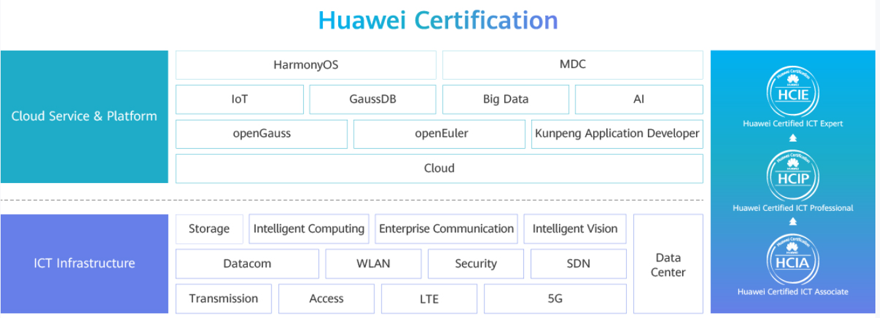

About This Document

Overview

This document describes how to install and deploy the HCIA-Storage lab environment to support the HCIA-Storage V5.0 scenario-based practices.

You are advised to deploy two servers, one Ethernet switch, one Huawei all-flash storage device, and (optional) one maintenance terminal for each lab environment.

https://download.huawei.com/mdl/imgDownload?uuid=9bce549b513c40deb19f2079c2e9c719Note:

The lab environment must have at least one Huawei storage device (such as Huawei OceanStor Dorado V6), one Ethernet switch, one Windows host, and one Linux host. Windows and Linux are installed on the two servers respectively. Alternatively, you can deploy virtual environments such as FusionCompute to create multiple Windows and Linux VMs. The maintenance terminal can be an independent Windows host or laptop.

Contents

[1 Device List 5](#_Toc117599802)

[1.1 Device Information 5](#_Toc117599803)

[2 Hardware and Software Information 6](#_Toc117599804)

[2.1 Hardware information 6](#_Toc117599805)

[2.2 Software Information 6](#_Toc117599806)

[2.3 Data Planning 7](#_Toc117599807)

[3 Operation Process 8](#_Toc117599808)

[3.1 Networking Topology 8](#_Toc117599809)

[3.2 Network Plan 8](#_Toc117599810)

[3.3 Operation Flowchart 10](#_Toc117599811)

[4 Key Procedure 11](#_Toc117599812)

[4.1 Installing and Connecting Devices 11](#_Toc117599813)

[4.2 Configuring the Switch 13](#_Toc117599814)

[4.3 (Optional) Deploying a Virtualization Platform 13](#_Toc117599815)

[4.4 Installing the Server OS 14](#_Toc117599816)

# Device List

## Device Information

For details about the devices, see the *HCIA-Storage V5.0 Device List (Physical Environment)*.

# Hardware and Software Information

## Hardware information

The following table is for reference.

Device information

|  |  |  |  |
| --- | --- | --- | --- |
| **Device Name** | **Device Model** | **Quantity** | **Remarks** |
| Huawei storage | Huawei OceanStor Dorado 3000 V6 | 1 | Recommended |
| Server | 2288H V5 | 2 | Windows and Linux operating systems are installed on the two servers respectively. |
| Ethernet switch | S5720 | 1 | -- |
| Maintenance terminal | -- | 1 | Used to configure or operate devices. Laptops or desktop PCs can be used. |

## Software Information

The following table lists the software that may be used in the lab environment for reference.

Software information

|  |  |  |
| --- | --- | --- |
| Name | Version | Remarks |
| PuTTY | PuTTY 0.74 | Recommended version |
| Windows server | Windows Server 2008 R2 | This version or a later version can be used. |
| Linux server | SUSE, CentOS, Red Hat, EulerOS | -- |

https://download.huawei.com/mdl/imgDownload?uuid=9bce549b513c40deb19f2079c2e9c719Software download addresses (for reference):

PuTTY: You are advised to use open-source software PuTTY to log in to a terminal. You can use the common domain name (**putty.org**) of PuTTY to browse or download the desired document or tool.

## Data Planning

The following table lists the accounts of main devices in the lab environment for reference.

Account information

|  |  |  |
| --- | --- | --- |
| **System Name** | **User Name/Password** | **Remarks** |
| Huawei storage | admin/Huawei12#$ | Recommended configuration |
| Linux | root/Huawei12#$ | Recommended configuration |
| Windows | Administrator/Huawei12#$ | Recommended configuration |

# Operation Process

## Networking Topology

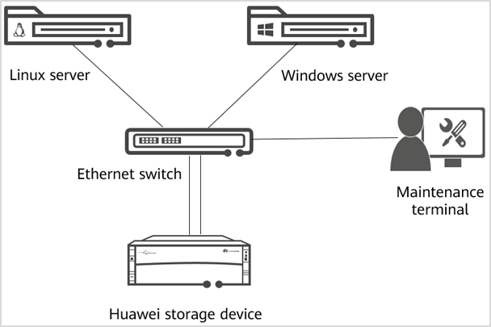

Networking topology

This figure shows the topology of the HCIA-Storage lab environment.

You are advised to deploy two servers, one Ethernet switch, one Huawei all-flash storage device, and one maintenance terminal for each lab environment.

## Network Plan

The network of the lab environment consists of a management plane and a service plane, which are used for device management and service access, respectively. The following table lists the IP addresses planned for the lab environment (for reference only).

The IP address of maintenance terminal can be configured on the management plane, for example, 192.168.10.31/24.

IP address plan

| **Device** | **Device Information** | **IP Address** | **Gateway** | **VLAN** |
| --- | --- | --- | --- | --- |
| Management plane | Storage controller A | 192.168.10.10 | 192.168.10.254 | VLAN 10 |
| Storage controller B | 192.168.10.11 | 192.168.10.254 | VLAN 10 |
| Linux server (iBMC management port) | 192.168.10.21 | 192.168.10.254 | VLAN 10 |
| Windows server (iBMC management port) | 192.168.10.22 | 192.168.10.254 | VLAN 10 |
| Service plane | Storage controller A | 192.168.20.10 | 192.168.20.254 | VLAN 20 |
| Storage controller B | 192.168.20.11 | 192.168.20.254 | VLAN 20 |
| Linux server | 192.168.20.21 | 192.168.20.254 | VLAN 20 |
| Windows server | 192.168.20.22 | 192.168.20.254 | VLAN 20 |

https://download.huawei.com/mdl/imgDownload?uuid=9bce549b513c40deb19f2079c2e9c719Note:

Huawei Intelligent Baseboard Management Controller (iBMC) is a remote management system for servers. It provides various management functions, such as management interfaces, fault monitoring and diagnosis, and power management. You can also use the iBMC to install and deploy operating systems.

[Reference Network]:

Refer to the following table for the network connections between devices. The service network uses ports 1 to 4, the management network uses ports 5 to 8, and the maintenance terminal uses port 9.

Device cabling diagram

| Device | Port |
| --- | --- |
| Switch | /home/admin/backup/lld-gw/202008241419/lld-gw/webserver/webapps/ROOT/65377/ips73151.pn |
|
| Linux server | /home/admin/backup/lld-gw/202008241419/lld-gw/webserver/webapps/ROOT/65377/host98403.pn |
|
|
|
|
| Windows server | /home/admin/backup/lld-gw/202008241419/lld-gw/webserver/webapps/ROOT/65377/host98404.pn |
|
|
|
|
| Storage device | /home/admin/backup/lld-gw/202008241419/lld-gw/webserver/webapps/ROOT/65377/storage59169.pn |
|
|
|

## Operation Flowchart

To set up the lab environment, you must install devices, configure the Ethernet switch, connect cables between devices, and install the server OSs. Alternatively, you can install a virtualization platform, such as FusionCompute, on the servers and then deploy OSs on the virtualization platform.

The following flowchart is for reference.

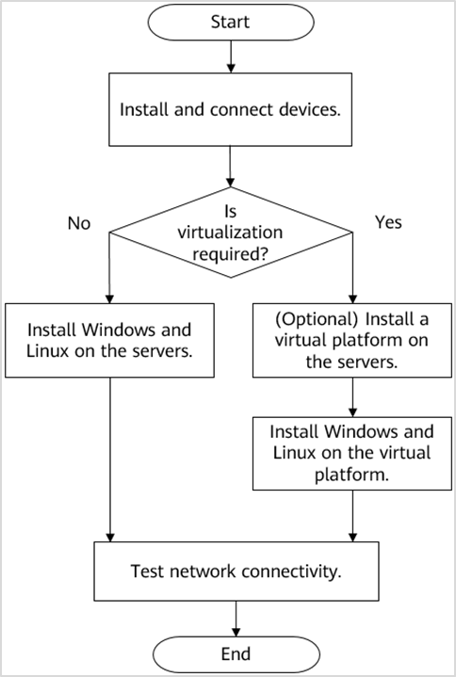

Installation process

# Key Procedure

This chapter describes the key steps to set up the lab environment. You can refer to section 3.3 Operation Flowchart.

## Installing and Connecting Devices

You must first install the devices and set up the network between them. According to the device list, you can set up the network by referring to the quick installation guides. For details, see the following documents:

[Reference Document]

*OceanStor Dorado 3000 V6, Dorado 5000 V6, and Dorado 6000 V6 Product Documentation*, *FusionServer Pro Rack Server Product Documentation*, and *S2750, S5700, and S6700 Series Switches Product Documentation*

https://download.huawei.com/mdl/imgDownload?uuid=9bce549b513c40deb19f2079c2e9c719Note:

You can log in to Huawei's technical support website (<https://support.huawei.com/enterprise/>) and input the name of a document or tool (such as **Dorado 3000**) in the search box to search for, browse, and download the desired document or tool.

Install the storage device.

Install the storage device.

[Suggested Procedure]

For details, see **Install and Initialize** > **Quick Installation Guide** in the product documentation.

https://download.huawei.com/mdl/imgDownload?uuid=9bce549b513c40deb19f2079c2e9c719Note:

For details on how to initialize the storage device, see **Install and Initialize** > **Initialization Guide** > **Logging In and Starting Initialization** > **Initially Configuring a Storage Device** in the product documentation.

Change the management IP address of the storage device.

Change the management IP address of the storage device according to the IP address plan.

[Suggested Procedure]

For details, see **Install and Initialize** > **Initialization Guide** > **Logging In and Starting Initialization** > **Changing IP Addresses of Management Network Ports** > **Changing IP Addresses of Management Network Ports Using a Serial Port** in the product documentation. Change the management IP address of the storage device according to the IP address plan.

https://download.huawei.com/mdl/imgDownload?uuid=9bce549b513c40deb19f2079c2e9c719Note:

The default user name and password of Huawei storage devices are **admin** and **Admin@storage**, respectively.

Install the servers.

Install the two servers.

[Suggested Procedure]

For details, see **Huawei FusionServer V5 Rack Server User Guide** > **2288H V5 Server User Guide** > **Installation and Configuration** > **Hardware Installation** in the product documentation.

Change the iBMC IP addresses of the servers.

Change the iBMC IP addresses of the servers according to the IP address plan.

[Suggested Procedure]

For details, see **Huawei FusionServer V5 Rack Server User Guide** > **2288H V5 Server User Guide** > **Installation and Configuration** > **Hardware Installation** in the product documentation.

https://download.huawei.com/mdl/imgDownload?uuid=9bce549b513c40deb19f2079c2e9c719Note:

For details, see the *FusionServer Pro Rack Server iBMC User Guide*. You can log in to Huawei's technical support website (<https://support.huawei.com/enterprise/>) and input the name of a document or tool (such as **iBMC**) in the search box to search for, browse, and download the desired document or tool.

Install the switch.

Install the Ethernet switch.

[Suggested Procedure]

For details, see **Installation** > **Hardware Installation and Maintenance Guide** > **Installing a Switch** in the product documentation.

Connect the devices.

After the devices are installed, connect them according to section 3.1 Network Topology and section 3.2 Network Plan.

## Configuring the Switch

Configure the Ethernet switch for proper communication between the storage device and servers.

Configure the Ethernet switch.

Log in to the switch and configure VLANs by referring to the network plan section.

For details about switch configuration specifications, see IP address and device connection planning in section 3.2.

[Suggested Procedure]

For details, see the following:

**Getting Started** > **Quick Configuration Guide** in the product documentation

**Configuration** > **CLI-based Configuration Guide** > **Ethernet Switching Configuration Guide** > **VLAN Configuration** > **Configuring VLAN** > **Assigning a LAN to VLANs** > **Dividing a LAN into VLANs Based on Ports (Statically Configured Link Type)** in the product documentation

Test the network.

Test the network after switch configuration is complete. For example, check whether the management IP address can be pinged on the maintenance terminal.

[Suggested Procedure]

Use the **ping** command to check network connectivity.

## (Optional) Deploying a Virtualization Platform

You can deploy a virtualization platform, such as Huawei FusionCompute, on the servers (if the server configuration meets the virtualization requirements) and then provision VMs.

Deploy a virtualization platform.

Install and deploy the Huawei FusionCompute virtualization platform on the servers.

[Suggested Procedure]

For details, see **Installation and Configuration** > **Installation Guide** > **Manual Installation** > **Installing FusionCompute** in the product documentation.

https://download.huawei.com/mdl/imgDownload?uuid=9bce549b513c40deb19f2079c2e9c719Note:

You can log in to Huawei's technical support website (<https://support.huawei.com/enterprise/>) and input the name of a document or tool (such as **FusionCompute**) in the search box to search for, browse, and download the desired document or tool.

## Installing the Server OS

Install Windows or Linux on the Huawei 2288H V5 server. After installation, you can log in to the system as the administrator.

Install Linux.

Install Linux on the server to mount storage services (such as LUNs). After installation, you can log in to the host as the root user.

[Suggested Procedure]

For details, see **Reference Documents** > **Reference Documents (General)** > **Huawei Server OS Installation Guide** > **Installing an OS Using the Installation DVD-ROM or ISO File** > **Installing an OS** in the *FusionServer Pro Rack Server Product Documentation*.

https://download.huawei.com/mdl/imgDownload?uuid=9bce549b513c40deb19f2079c2e9c719Note:

Huawei storage supports multiple Linux OSs, such as SUSE, Red Hat, and EulerOS.

Install Windows.

Install Windows on the other server to mount storage services (such as LUNs). After installation, you can log in to the host as the administrator.

[Suggested Procedure]

For details, see **Installing the OS** > **Installing the OS in Legacy Mode** in the *Windows Server 2016 Installation Guide*.

https://download.huawei.com/mdl/imgDownload?uuid=9bce549b513c40deb19f2079c2e9c719Note:

You can log in to Huawei's technical support website (<https://support.huawei.com/enterprise/>) and input the name of a document or tool (such as Windows Server 2016 Installation Guide) in the search box and select **Community** to search for, browse, and download the desired document or tool.

Test the network.

Configure IP addresses for the servers and test the network.

[Suggested Procedure]

Use the **ping** command in the OS to check network connectivity.

https://download.huawei.com/mdl/imgDownload?uuid=9bce549b513c40deb19f2079c2e9c719Note:

You must disable the firewall on the Windows server. Otherwise, the IP address cannot be pinged.