Huawei Storage Certification Training

HCIA-Storage

SmartQoS

Scenario-based Practice

(For Trainees)



HUAWEI TECHNOLOGIES CO., LTD.

|  |
| --- |
| **Copyright © Huawei Technologies Co., Ltd. 2020. All rights reserved.**  No part of this document may be reproduced or transmitted in any form or by any means without prior written consent of Huawei Technologies Co., Ltd.  **Trademarks and Permissions**  HW_POS_RBG_Vertical-150ppi and other Huawei trademarks are trademarks of Huawei Technologies Co., Ltd.  All other trademarks and trade names mentioned in this document are the property of their respective holders.  **Notice**  The purchased products, services and features are stipulated by the contract made between Huawei and the customer. All or part of the products, services and features described in this document may not be within the purchase scope or the usage scope. Unless otherwise specified in the contract, all statements, information, and recommendations in this document are provided "AS IS" without warranties, guarantees or representations of any kind, either express or implied.  The information in this document is subject to change without notice. Every effort has been made in the preparation of this document to ensure accuracy of the contents, but all statements, information, and recommendations in this document do not constitute a warranty of any kind, express or implied. |

|  |  |
| --- | --- |
| **Huawei Technologies Co., Ltd.** | |
| Address: | Huawei Industrial Base Bantian, Longgang Shenzhen 518129  People's Republic of China |
| Website: | http://[e](http://e.huawei.com/).huawei.com |

**Huawei Certification System**

Huawei Certification follows the "platform + ecosystem" development strategy, which is a new collaborative architecture of ICT infrastructure based on "Cloud-Pipe-Terminal". Huawei has set up a complete certification system comprising three categories: ICT infrastructure, Platform and Service, and ICT vertical. Huawei's technical certification system is the only one in the industry covering all of these fields.

Huawei offers three levels of certification: Huawei Certified ICT Associate (HCIA), Huawei Certified ICT Professional (HCIP), and Huawei Certified ICT Expert (HCIE).

Huawei Certified ICT Associate-Storage (HCIA-Storage) is designed for Huawei engineers, students and ICT industry personnel. HCIA-Storage covers storage technology trends, basic storage technologies, common advanced storage technologies, business continuity solutions for storage and storage system O&M management.

The HCIA-Storage certificate introduces you to the storage industry and markets, helps you understand sector innovation, and makes sure you stand out among your industry peers.

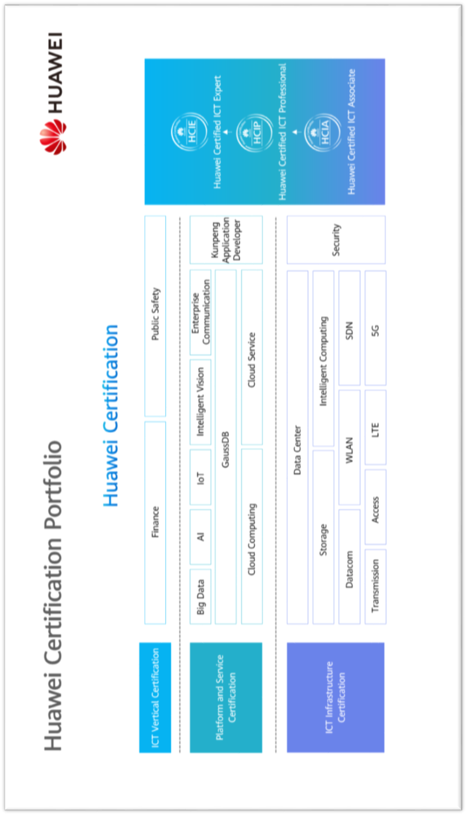

Contents

[1 References and Tools 4](#_Toc49432122)

[1.1 References 4](#_Toc49432123)

[1.2 Software Tools 4](#_Toc49432124)

[1.3 Version Description 4](#_Toc49432125)

[2 Scenario-based Practice on SmartQoS 5](#_Toc49432126)

[2.1 Course Overview 5](#_Toc49432127)

[2.2 Objectives 5](#_Toc49432128)

[2.3 Case Background 5](#_Toc49432129)

[2.4 Tasks 6](#_Toc49432130)

[2.4.1 Scenario: Using SmartQoS 6](#_Toc49432131)

[2.5 Summary and Conclusion 10](#_Toc49432132)

# References and Tools

## References

The commands, documents, and document paths listed in this document are for reference only. The actual commands, documents, and document paths may vary.

Huawei OceanStor Dorado V6 Product Documentation



The specifications of SmartQoS vary by product. For details, see the product documentation of the desired product model. You can log in to Huawei's technical support website (<https://support.huawei.com/enterprise/>) and use the search box to find and download the desired document or tool.

## Software Tools

PuTTY



You are advised to use the open-source software PuTTY to log in to a terminal. You can visit its public website (putty.org) to find and download the desired document or tool.

## Version Description

| **Name** | **Version** | **Quantity** | **Remarks** |
| --- | --- | --- | --- |
| Storage device | Huawei OceanStor Dorado V6 | 1 |  |
| Windows OS | Windows Server 2012, Windows Server 2016 | -- | Recommended version |
| Linux OS | SUSE, Red Hat, CentOS, EulerOS | -- | Recommended version |

# Scenario-based Practice on SmartQoS

## Course Overview

This course provides case study and scenario-based practices to help trainees consolidate their knowledge on the use of SmartQoS. SmartQoS is a common advanced storage technology. Before using SmartQoS, you are advised to learn how to configure basic storage services.

## Objectives

* To understand suitable application scenarios for SmartQoS
* To be able to configure SmartQoS

## Case Background



Cases in this document are examples only. The actual configurations may vary according to actual environments. For details, see the corresponding product documentation. The names of storage pools and LUNs involved in this document can be customized (for example, LUN \_XXX) for different trainees if they use the same device.

A company uses a Huawei OceanStor all-flash storage device to run services. Multiple LUNs have been created to support different services. LUN\_0 mapped to the Linux service host carries critical services, and LUN\_1 and LUN\_2, which are mapped to the Windows host, carry non-critical services. To ensure that LUN\_0 has preferential access to storage resources, the company purchases SmartQoS.

Help the storage engineers become familiar with operations related to SmartQoS.

The following figure shows the company's live network topology.

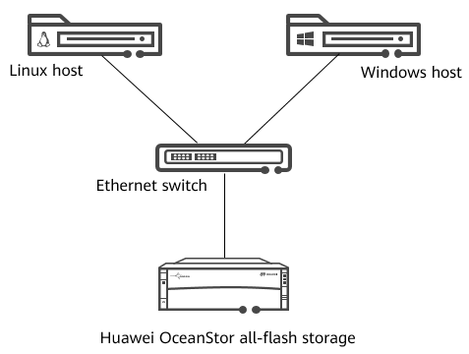

Network topology

## Tasks

### Scenario: Using SmartQoS

Background

SmartQoS is configured to accurately limit the performance of applications and prevent non-critical applications from competing for excessive storage resources.

Question

How do we set indicators (bandwidth and IOPS) to implement traffic control?

Task 1: Configuring SmartQoS

Help the engineer configure SmartQoS.

Draw a flowchart for configuring SmartQoS.

Demonstrate how to configure SmartQoS.

|  |
| --- |
|  |

[Suggested Procedure]

For details about drawing flowcharts, see **Configure** > **SmartQoS Feature Guide** > **Configuring SmartQoS** > **Configuration Process** in the product documentation.

View SmartQoS license information.

Before configuring SmartQoS, ensure that permission to use SmartQoS has been granted. Help the engineer check the SmartQoS license information.

|  |
| --- |
|  |

[Suggested Procedure]

For details about operations on DeviceManager, see **Configure** > **SmartQoS Feature Guide** > **Configuring SmartQoS** > **Checking the SmartQoS License** in the product documentation.

For details about operations on the CLI, see **Reference** > **Command Reference** > **License Management Commands** > **license** > **show license** in the product documentation.

For details about how to log in to the CLI of storage systems, see **Reference** > **Advanced O&M Command Reference** > **CLI Use Guidance** > **Logging In to the CLI of the Storage System** in the product documentation.

Monitor service performance.

Find the I/O characteristics of the LUNs using the storage system's service monitoring function and use these characteristics to create SmartQoS policies. See how many IOPS the LUNs deliver in total.

|  |
| --- |
|  |

[Suggested Procedure]

For details about operations on DeviceManager, see **Configure** > **SmartQoS Feature Guide** > **Configuring SmartQoS** > **Monitoring Application Performance** in the product documentation.

Create a SmartQoS policy.

After analyzing the performance monitoring data, the engineer concludes that the IOPS of **LUN\_1** should be within 200. Help the engineer configure SmartQoS policy **Policy01** to set the maximum IOPS to 200.

|  |
| --- |
|  |

[Suggested Procedure]

For details about operations on DeviceManager, see **Configure** > **SmartQoS Feature Guide** > **Configuring SmartQoS** > **Creating a SmartQoS Policy** in the product documentation.

Question

How can the SmartQoS policy be adjusted based on the performance data of LUNs?

Task 2: Managing SmartQoS

After configuring SmartQoS, the engineer needs to manage SmartQoS to adjust data flows and properly allocate storage resources. Explain to the engineer how to manage SmartQoS.

Add a control object.

On DeviceManager, you can add new control objects to the SmartQoS policy as required. Add control object **LUN\_2** to **Policy01**.

|  |
| --- |
|  |

[Suggested Procedure]

For details about operations on DeviceManager, see **Configure** > **SmartQoS Feature Guide** > **Managing SmartQoS** > **Adding a Control Object** in the product documentation.

Remove a control object.

On DeviceManager, you can remove control objects from a SmartQoS policy as required. Remove control object **LUN\_2** from **Policy01**.

|  |
| --- |
|  |

[Suggested Procedure]

For details about operations on DeviceManager, see **Configure** > **SmartQoS Feature Guide** > **Managing SmartQoS** > **Removing a Control Object** in the product documentation.

Activate and deactivate a SmartQoS policy.

A SmartQoS policy can take effect in accordance with its trigger policy after it has been activated. In a storage system where only one type of applications is available or all LUNs or LUN groups need the same amount of resources, you can deactivate SmartQoS policies because adjusting and controlling performance of I/O classes is unnecessary. Help the engineer get familiar with the activation and deactivation of **Policy01**.

|  |
| --- |
|  |

[Suggested Procedure]

For details about operations on DeviceManager, see **Configure** > **SmartQoS Feature Guide** > **Managing SmartQoS** > **Activating Creating a SmartQoS Policy** and **Deactivating a SmartQoS Policy** in the product documentation.

Modify a SmartQoS policy.

In off-peak hours, the engineer considers that the IOPS limit for non-critical services can be adjusted to 300. Help the engineer change the maximum IOPS limit to 300 for **Policy01**.

|  |
| --- |
|  |

[Suggested Procedure]

For details about operations on DeviceManager, see **Configure** > **SmartQoS Feature Guide** > **Managing SmartQoS** > **Modifying a SmartQoS Policy** in the product documentation.

Delete a SmartQoS policy.

As the company develops, critical services are migrated to other storage devices and do not need to compete for resources with non-critical services. Therefore, the original SmartQoS policy can be deleted. Help the engineer delete SmartQoS policy **Policy01**.

|  |
| --- |
|  |

[Suggested Procedure]

For details about operations on DeviceManager, see **Configure** > **SmartQoS Feature Guide** > **Managing SmartQoS** > **Deleting a SmartQoS Policy** in the product documentation.

Discussion

In a storage system, what are the performance indicators and how can they be used?

## Summary and Conclusion

My Opinion:

\_\_\_\_\_\_\_\_\_\_\_\_\_\_\_\_\_\_\_\_\_\_\_\_\_\_\_\_\_\_\_\_\_\_\_\_\_\_\_\_\_\_\_\_\_\_\_\_\_\_\_\_\_\_\_\_\_\_\_\_\_\_\_\_\_\_\_\_\_\_\_\_\_\_\_\_\_\_\_\_\_\_\_\_\_\_\_\_\_\_\_\_\_\_\_\_\_\_\_\_\_\_\_\_\_\_\_\_\_\_\_\_\_\_\_\_\_\_\_\_\_\_\_\_\_\_\_\_\_\_\_\_\_\_\_\_\_\_\_\_\_\_\_\_\_\_\_\_\_\_\_\_\_\_\_\_\_\_\_\_\_\_\_\_\_\_\_\_\_\_\_\_\_\_\_\_\_\_\_\_\_\_\_\_\_\_\_\_\_\_\_\_\_\_\_\_\_\_\_\_\_\_\_\_\_\_\_\_\_\_\_\_\_\_\_\_\_\_\_\_\_\_\_\_\_\_\_\_\_\_\_\_\_\_\_\_\_\_\_\_\_\_\_\_