Huawei Storage Certification Training

HCIA-Storage

SmartMigration

Scenario-based Practice

(For Trainees)



HUAWEI TECHNOLOGIES CO., LTD.

|  |
| --- |
| **Copyright © Huawei Technologies Co., Ltd. 2020. All rights reserved.**  No part of this document may be reproduced or transmitted in any form or by any means without prior written consent of Huawei Technologies Co., Ltd.  **Trademarks and Permissions**  HW_POS_RBG_Vertical-150ppi and other Huawei trademarks are trademarks of Huawei Technologies Co., Ltd.  All other trademarks and trade names mentioned in this document are the property of their respective holders.  **Notice**  The purchased products, services and features are stipulated by the contract made between Huawei and the customer. All or part of the products, services and features described in this document may not be within the purchase scope or the usage scope. Unless otherwise specified in the contract, all statements, information, and recommendations in this document are provided "AS IS" without warranties, guarantees or representations of any kind, either express or implied.  The information in this document is subject to change without notice. Every effort has been made in the preparation of this document to ensure accuracy of the contents, but all statements, information, and recommendations in this document do not constitute a warranty of any kind, express or implied. |

|  |  |
| --- | --- |
| **Huawei Technologies Co., Ltd.** | |
| Address: | Huawei Industrial Base Bantian, Longgang Shenzhen 518129  People's Republic of China |
| Website: | http://[e](http://e.huawei.com/).huawei.com |

**Huawei Certification System**

Huawei Certification follows the "platform + ecosystem" development strategy, which is a new collaborative architecture of ICT infrastructure based on "Cloud-Pipe-Terminal". Huawei has set up a complete certification system comprising three categories: ICT infrastructure, Platform and Service, and ICT vertical. Huawei's technical certification system is the only one in the industry covering all of these fields.

Huawei offers three levels of certification: Huawei Certified ICT Associate (HCIA), Huawei Certified ICT Professional (HCIP), and Huawei Certified ICT Expert (HCIE).

Huawei Certified ICT Associate-Storage (HCIA-Storage) is designed for Huawei engineers, students and ICT industry personnel. HCIA-Storage covers storage technology trends, basic storage technologies, common advanced storage technologies, business continuity solutions for storage and storage system O&M management.

The HCIA-Storage certificate introduces you to the storage industry and markets, helps you understand sector innovation, and makes sure you stand out among your industry peers.

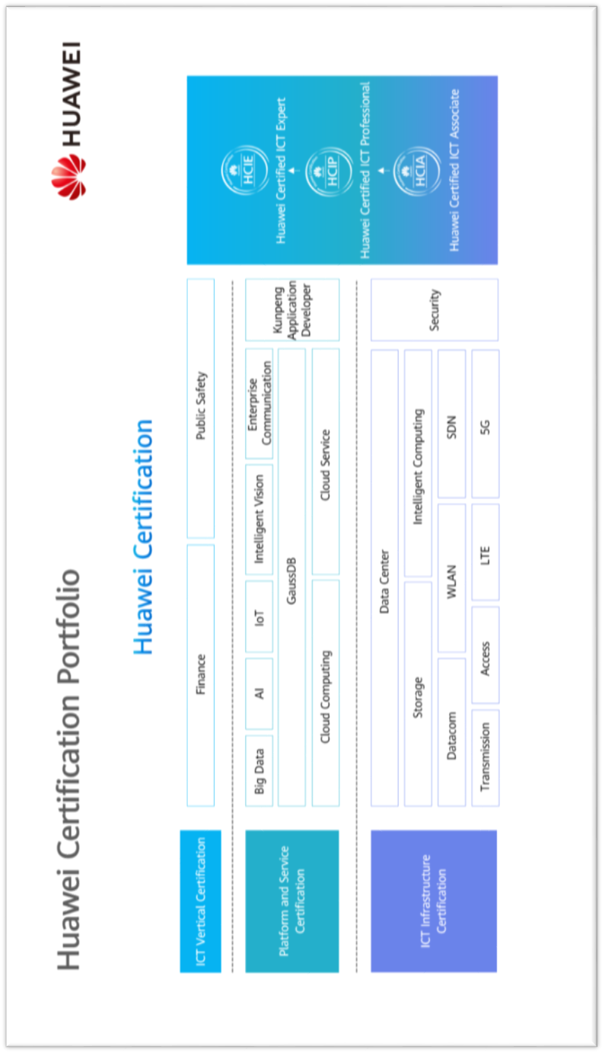

Contents

[1 References and Tools 4](#_Toc49433773)

[1.1 References 4](#_Toc49433774)

[1.2 Software Tools 4](#_Toc49433775)

[1.3 Version Description 4](#_Toc49433776)

[2 Scenario-based Practice on SmartMigration 5](#_Toc49433777)

[2.1 Course Overview 5](#_Toc49433778)

[2.2 Objectives 5](#_Toc49433779)

[2.3 Case Background 5](#_Toc49433780)

[2.4 Tasks 6](#_Toc49433781)

[2.4.1 Scenario: Using SmartMigration 6](#_Toc49433782)

[2.5 Summary and Conclusion 9](#_Toc49433783)

# References and Tools

## References

The commands, documents, and document paths listed in this document are for reference only. The actual commands, documents, and document paths may vary.

Huawei OceanStor Dorado V6 Product Documentation



The specifications of SmartMigration vary by product. For details, see the product documentation of the desired product model. You can log in to Huawei's technical support website (<https://support.huawei.com/enterprise/>) and use the search box to find and download the desired document or tool.

## Software Tools

PuTTY



You are advised to use the open-source software PuTTY to log in to a terminal. You can visit its public website (putty.org) to find and download the desired document or tool.

## Version Description

| **Name** | **Version** | **Quantity** | **Remarks** |
| --- | --- | --- | --- |
| Storage device | Huawei OceanStor Dorado V6 | 1 |  |
| Windows OS | Windows Server 2012, Windows Server 2016 | -- | Recommended version |
| Linux OS | SUSE, Red Hat, CentOS, EulerOS | -- | Recommended version |

# Scenario-based Practice on SmartMigration

## Course Overview

This course provides case study and scenario-based practices to help trainees consolidate their knowledge on the use of SmartMigration. SmartMigration is a common advanced storage technology. Before using SmartMigration, you are advised to learn how to configure basic storage services.

## Objectives

* To understand suitable application scenarios for SmartMigration
* To be able to configure SmartMigration

## Case Background



Cases in this document are examples only. The actual configurations may vary according to actual environments. For details, see the corresponding product documentation. The names of storage pools and LUNs involved in this document can be customized (for example, LUN \_XXX) for different trainees if they use the same device.

An enterprise has a Huawei OceanStor all-flash storage device and purchases SmartMigration for data migration.

Help the storage engineers become familiar with operations related to SmartMigration.

The following figure shows the company's live network topology.

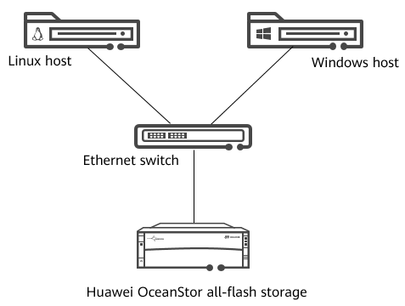

Network topology

## Tasks

### Scenario: Using SmartMigration

Background

The enterprise creates two storage pools named **SP\_ SOUR** and **SP\_DEST**. A storage engineer maps a 5 GB LUN named **LUN\_SOUR** in storage pool **SP\_SOUR** to the host. A file system has been created for **LUN\_SOUR** on the host and has been mounted. A text file **A.txt** containing characters has been written to **LUN\_SOUR**. Data in **LUN\_SOUR** is to be migrated to **LUN\_DEST**.

Question

What are the differences between SmartMigration and HyperClone?

Task 1: Configuring SmartMigration

Help the engineer configure SmartMigration.

Draw a flowchart for configuring SmartMigration.

Demonstrate how to configure SmartMigration.

|  |
| --- |
|  |

[Suggested Procedure]

For details about how to draw a flowchart, see **Configure** > **SmartMigration Feature Guide** > **Configuring SmartMigration Between Storage Systems** > **Configuration Process** in the product documentation.

View SmartMigration license information.

Before configuring SmartMigration, ensure that permission to use SmartMigration has been granted. Help the engineer check the SmartMigration license information.

|  |
| --- |
|  |

[Suggested Procedure]

For details about operations on DeviceManager, see **Configure** > **SmartMigration Feature Guide** > **Configuring SmartMigration Between Storage Systems** > **Checking the License File** in the product documentation.

For details about operations on the CLI, see **Reference** > **Command Reference** > **License Management Commands** > **license** > **show license** in the product documentation.

Create a SmartMigration task.

Help the engineer create a SmartMigration task. **Use LUN\_SOUR** as the source LUN and select **SP\_DEST** as the storage pool where the target LUN resides. Set the migration rate to **Low** and split mode to **Manual**.

|  |
| --- |
|  |

[Suggested Procedure]

For details about operations on DeviceManager, see **Configure** > **SmartMigration Feature Guide** > **Configuring SmartMigration Between Storage Systems** > **Creating a SmartMigration Task** in the product documentation.

For details about operations on the CLI, see **Reference** > **Command Reference** > **Storage Domain Management Commands** > **smart\_migration** > **create lun\_migration** in the product documentation.

Split a SmartMigration pair.

The target LUN can save the data copied from the source LUN at the split point in time only after the SmartMigration pair is split. The enterprise can use the data copy to test applications. Help the engineer split the SmartMigration pair and stop the synchronization between the source LUN and target LUN.

|  |
| --- |
|  |

[Suggested Procedure]

For details about operations on DeviceManager, see **Configure** > **SmartMigration Feature Guide** > **Configuring SmartMigration Between Storage Systems** > **Splitting a SmartMigration Pair** in the product documentation.

For details about operations on the CLI, see **Reference** > **Command Reference** > **Storage Domain Management Commands** > **smart\_migration** > **change lun\_migration\_split consistency** in the product documentation.

Question

Can SmartMigration be used to migrate data between heterogeneous storage systems?

Task 2: Managing SmartMigration

After configuring SmartMigration, help the engineer become familiar with snapshot management operations.

Modify the migration rate.

The engineer determines it is best to perform the migration at night when the service load is light. If the migration rate is **Low**, the migration may take a long time and affect services in the daytime. Help the engineer change the migration rate to **Highest**.

|  |
| --- |
|  |

[Suggested Procedure]

For details about operations on DeviceManager, see **Configure** > **SmartMigration Feature Guide** > **Managing SmartMigration** > **Modifying the Properties of a SmartMigration Task** in the product documentation.

For details about operations on the CLI, see **Reference** > **Command Reference** > **Storage Domain Management Commands** > **smart\_migration** > **change lun\_migration** in the product documentation.

Delete a SmartMigration task.

Help the engineer delete the SmartMigration task and redundant LUNs created during the migration.

|  |
| --- |
|  |

[Suggested Procedure]

For details about operations on DeviceManager, see **Configure** > **SmartMigration Feature Guide** > **Managing SmartMigration** > **Deleting a SmartMigration Task** in the product documentation.

For details about operations on the CLI, see **Reference** > **Command Reference** > **Storage Domain Management Commands** > **smart\_migration** > **delete lun\_migration** in the product documentation.

Discussion

In addition to the migration rate, what SmartMigration properties can be modified?

## Summary and Conclusion

My Opinion:

\_\_\_\_\_\_\_\_\_\_\_\_\_\_\_\_\_\_\_\_\_\_\_\_\_\_\_\_\_\_\_\_\_\_\_\_\_\_\_\_\_\_\_\_\_\_\_\_\_\_\_\_\_\_\_\_\_\_\_\_\_\_\_\_\_\_\_\_\_\_\_\_\_\_\_\_\_\_\_\_\_\_\_\_\_\_\_\_\_\_\_\_\_\_\_\_\_\_\_\_\_\_\_\_\_\_\_\_\_\_\_\_\_\_\_\_\_\_\_\_\_\_\_\_\_\_\_\_\_\_\_\_\_\_\_\_\_\_\_\_\_\_\_\_\_\_\_\_\_\_\_\_\_\_\_\_\_\_\_\_\_\_\_\_\_\_\_\_\_\_\_\_\_\_\_\_\_\_\_\_\_\_\_\_\_\_\_\_\_\_\_\_\_\_\_\_\_\_\_\_\_\_\_\_\_\_\_\_\_\_\_\_\_\_\_\_\_\_\_\_\_\_\_\_\_\_\_\_\_\_\_\_\_\_\_\_\_\_\_\_\_\_\_\_