Huawei Storage Certification Training

HCIA-Storage

HyperClone

Scenario-based Practice

(For Trainees)



HUAWEI TECHNOLOGIES CO., LTD.

|  |
| --- |
| **Copyright © Huawei Technologies Co., Ltd. 2020. All rights reserved.**  No part of this document may be reproduced or transmitted in any form or by any means without prior written consent of Huawei Technologies Co., Ltd.  **Trademarks and Permissions**  and other Huawei trademarks are trademarks of Huawei Technologies Co., Ltd.  All other trademarks and trade names mentioned in this document are the property of their respective holders.  **Notice**  The purchased products, services and features are stipulated by the contract made between Huawei and the customer. All or part of the products, services and features described in this document may not be within the purchase scope or the usage scope. Unless otherwise specified in the contract, all statements, information, and recommendations in this document are provided "AS IS" without warranties, guarantees or representations of any kind, either express or implied.  The information in this document is subject to change without notice. Every effort has been made in the preparation of this document to ensure accuracy of the contents, but all statements, information, and recommendations in this document do not constitute a warranty of any kind, express or implied. |

|  |  |
| --- | --- |
| **Huawei Technologies Co., Ltd.** | |
| Address: | Huawei Industrial Base Bantian, Longgang Shenzhen 518129  People's Republic of China |
| Website: | http://[e](http://e.huawei.com/).huawei.com |

**Huawei Certification System**

Huawei Certification follows the "platform + ecosystem" development strategy, which is a new collaborative architecture of ICT infrastructure based on "Cloud-Pipe-Terminal". Huawei has set up a complete certification system comprising three categories: ICT infrastructure, Platform and Service, and ICT vertical. Huawei's technical certification system is the only one in the industry covering all of these fields.

Huawei offers three levels of certification: Huawei Certified ICT Associate (HCIA), Huawei Certified ICT Professional (HCIP), and Huawei Certified ICT Expert (HCIE).

Huawei Certified ICT Associate-Storage (HCIA-Storage) is designed for Huawei engineers, students and ICT industry personnel. HCIA-Storage covers storage technology trends, basic storage technologies, common advanced storage technologies, business continuity solutions for storage and storage system O&M management.

The HCIA-Storage certificate introduces you to the storage industry and markets, helps you understand sector innovation, and makes sure you stand out among your industry peers.

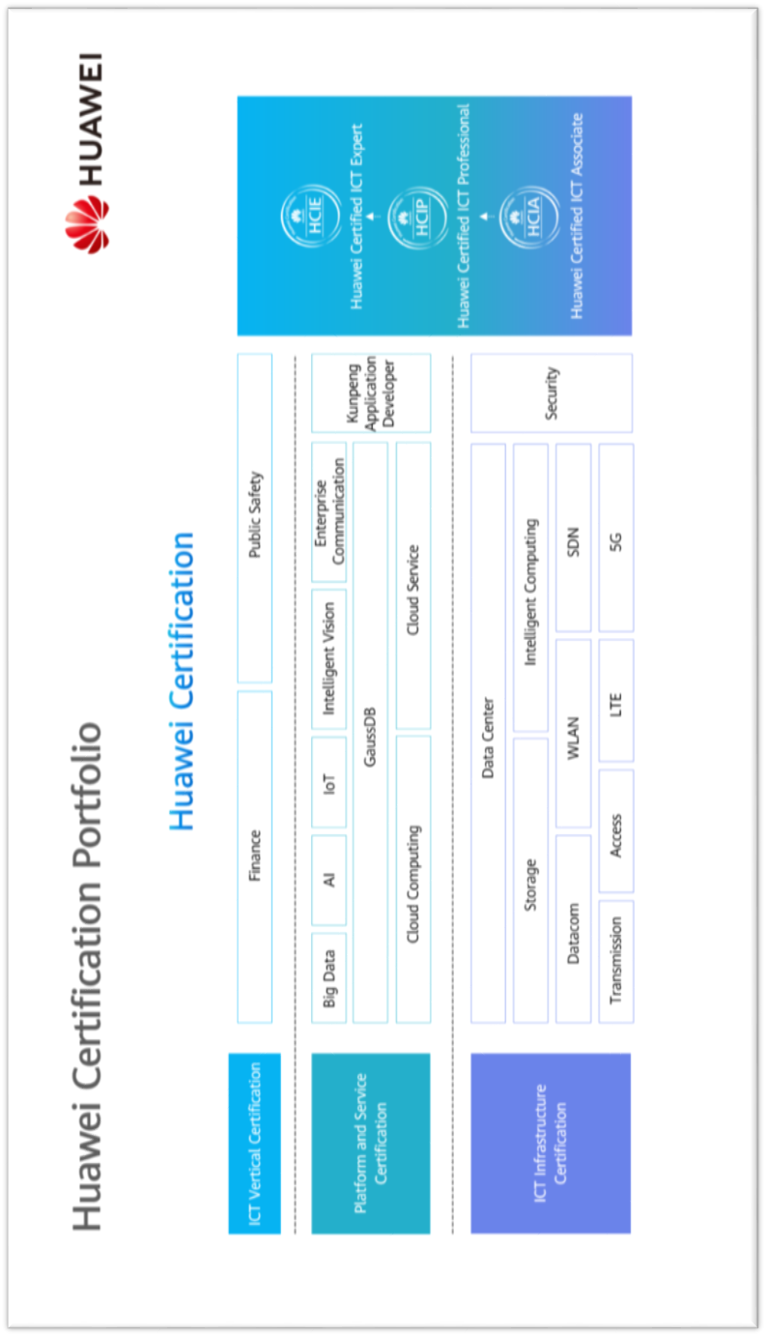

Contents

1 References and Tools 4

1.1 References 4

1.2 Software Tools 4

1.3 Version Description 4

2 Scenario-based Practice on HyperClone 5

2.1 Course Overview 5

2.2 Objectives 5

2.3 Case Background 5

2.4 Tasks 6

2.4.1 Scenario: Using HyperClone 6

2.5 Summary and Conclusion 9

# References and Tools

## References

The commands, documents, and document paths listed in this document are for reference only. The actual commands, documents, and document paths may vary.

Huawei OceanStor Dorado V6 Product Documentation



The specifications of HyperClone vary by product. For details, see the product documentation of the desired product model. You can log in to Huawei's technical support website (<https://support.huawei.com/enterprise/>) and use the search box to find and download the desired document or tool.

## Software Tools

PuTTY



You are advised to use the open-source software PuTTY to log in to a terminal. You can visit its public website (putty.org) to find and download the desired document or tool.

## Version Description

|  |  |  |  |
| --- | --- | --- | --- |
| **Name** | **Version** | **Quantity** | **Remarks** |
| Storage device | Huawei OceanStor Dorado V6 | 1 |  |
| Windows OS | Windows Server 2012, Windows Server 2016 | -- | Recommended version |
| Linux OS | SUSE, Red Hat, CentOS, EulerOS | -- | Recommended version |

# Scenario-based Practice on HyperClone

## Course Overview

This course provides case study and scenario-based practices to help trainees consolidate their knowledge on the use of HyperClone. HyperClone is a common advanced storage technology. Before using HyperClone, you are advised to learn how to configure basic storage services.

## Objectives

* To be able to configure HyperClone
* To understand how to manage clones

## Case Background



Cases in this document are examples only. The actual configurations may vary according to actual environments. For details, see the corresponding product documentation. The names of storage pools and LUNs involved in this document can be customized (for example, LUN _XXX) for different trainees if they use the same device.

An enterprise has a Huawei OceanStor all-flash storage device and has purchased a HyperClone license. Help the storage engineers become familiar with operations related to HyperClone.

The following figure shows the company's live network topology.

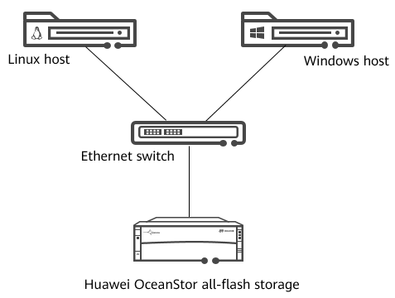

Network topology

## Tasks

### Scenario: Using HyperClone

Background

A 5 GB LUN named **LUN_SOUR** has been created and mapped to a host. A file system has been created for **LUN_SOUR** on the host and has been mounted. A text file **A.txt** containing characters has been written to **LUN_SOUR**.

Question

What is the difference between HyperClone and HyperSnap?

Task 1: Configuring HyperClone

Draw a flowchart for configuring HyperClone.

Demonstrate how to configure HyperClone.

|  |
| --- |
|  |

[Suggested Procedure]

For details about how to draw a flowchart, see **Configure** > **HyperClone Feature Guide** > **Configuring HyperClone** > **Configuration Process** in the product documentation.

View HyperClone license information.

Before configuring HyperClone, ensure that permission to use HyperClone has been granted. Help the engineer check the HyperClone license information.

|  |
| --- |
|  |

[Suggested Procedure]

For details about operations on DeviceManager, see **Configure** > **HyperClone Feature Guide** > **Configuring HyperClone** > **Checking the License** in the product documentation.

For details about operations on the CLI, see **Reference** > **Command Reference** > **License Management Commands** > **license** > **show license** in the product documentation.

Create a clone pair.

Help the engineer create a clone pair for **LUN_SOUR**. Set the target LUN name to **LUN_DEST**.

|  |
| --- |
|  |

[Suggested Procedure]

For details about operations on DeviceManager, see **Configure** > **HyperClone Feature Guide** > **Configuring HyperClone** > **Creating a Clone Pair** in the product documentation.

For details about operations on the CLI, see **Reference** > **Command Reference** > **Data Protection Management Commands** > **hyper_copy** > **create clone general** in the product documentation.

Question

In Huawei OceanStor all-flash storage systems, what will happen if the capacity of the source LUN is inconsistent with that of the target LUN in a clone pair?

Task 2: Managing HyperClone

In practice, unexpected situations may occur during the use of HyperClone, for example, the service load may increase sharply during clone synchronization. In such cases, the engineer should pause the synchronization and resume it when the service load is light. Explain to the engineer how to pause and resume clone synchronization.

Pause synchronization.

Help the engineer pause clone synchronization.

|  |
| --- |
|  |

[Suggested Procedure]

For details about operations on DeviceManager, see **Configure** > **HyperClone Feature Guide** > **Managing Clone Pairs** > **Pausing Synchronizing or Reversely Synchronizing a Clone Pair** in the product documentation.

For details about operations on the CLI, see **Reference** > **Command Reference** > **Data Protection Management Commands** > **hyper_copy** > **change clone restore** in the product documentation.

Resume synchronization.

Help the engineer resume clone synchronization.

|  |
| --- |
|  |

[Suggested Procedure]

For details about operations on DeviceManager, see **Configure** > **HyperClone Feature Guide** > **Managing Clone Pairs** > **Resuming Synchronizing or Reversely Synchronizing a Clone Pair** in the product documentation.

For details about operations on the CLI, see **Reference** > **Command Reference** > **Data Protection Management Commands** > **hyper_copy** > **change clone restore** in the product documentation.

Delete a clone pair.

After completing the preceding operations, delete the clone pair.

|  |
| --- |
|  |

[Suggested Procedure]

For details about operations on DeviceManager, see **Configure** > **HyperClone Feature Guide** > **Managing Clone Pairs** > **Deleting a Clone Pair** in the product documentation.

For details about operations on the CLI, see **Reference** > **Command Reference** > **Data Protection Management Commands** > **hyper_copy** > **delete clone** in the product documentation.

Discussion

After clone synchronization is complete, can users perform synchronization again?

## Summary and Conclusion

My Opinion:

____________________________________________________________________________________________________________________________________________________________________________________________________________________________________________________