Huawei Storage Certification Training

HCIA-Storage
Scenario-based Practice of Storage O&M Management

(For Trainees)

HUAWEI TECHNOLOGIES CO., LTD.

Copyright © Huawei Technologies Co., Ltd. 2020. All rights reserved.
No part of this document may be reproduced or transmitted in any form or by any means without prior written consent of Huawei Technologies Co., Ltd.

Trademarks and Permissions
and other Huawei trademarks are trademarks of Huawei Technologies Co., Ltd.
All other trademarks and trade names mentioned in this document are the property of their respective holders.

Notice
The purchased products, services and features are stipulated by the contract made between Huawei and the customer. All or part of the products, services and features described in this document may not be within the purchase scope or the usage scope. Unless otherwise specified in the contract, all statements, information, and recommendations in this document are provided "AS IS" without warranties, guarantees or representations of any kind, either express or implied.
The information in this document is subject to change without notice. Every effort has been made in the preparation of this document to ensure accuracy of the contents, but all statements, information, and recommendations in this document do not constitute a warranty of any kind, express or implied.

Huawei Technologies Co., Ltd.
Address: | Huawei Industrial Base Bantian, Longgang Shenzhen 518129  People's Republic of China
Website: | http://e.huawei.com

Huawei Certification System
Huawei Certification follows the "platform + ecosystem" development strategy, which is a new collaborative architecture of ICT infrastructure based on "Cloud-Pipe-Terminal". Huawei has set up a complete certification system comprising three categories: ICT infrastructure, Platform and Service, and ICT vertical. Huawei's technical certification system is the only one in the industry covering all of these fields.
Huawei offers three levels of certification: Huawei Certified ICT Associate (HCIA), Huawei Certified ICT Professional (HCIP), and Huawei Certified ICT Expert (HCIE).
Huawei Certified ICT Associate-Storage (HCIA-Storage) is designed for Huawei engineers, students and ICT industry personnel. HCIA-Storage covers storage technology trends, basic storage technologies, common advanced storage technologies, business continuity solutions for storage and storage system O&M management.
The HCIA-Storage certificate introduces you to the storage industry and markets, helps you understand sector innovation, and makes sure you stand out among your industry peers.
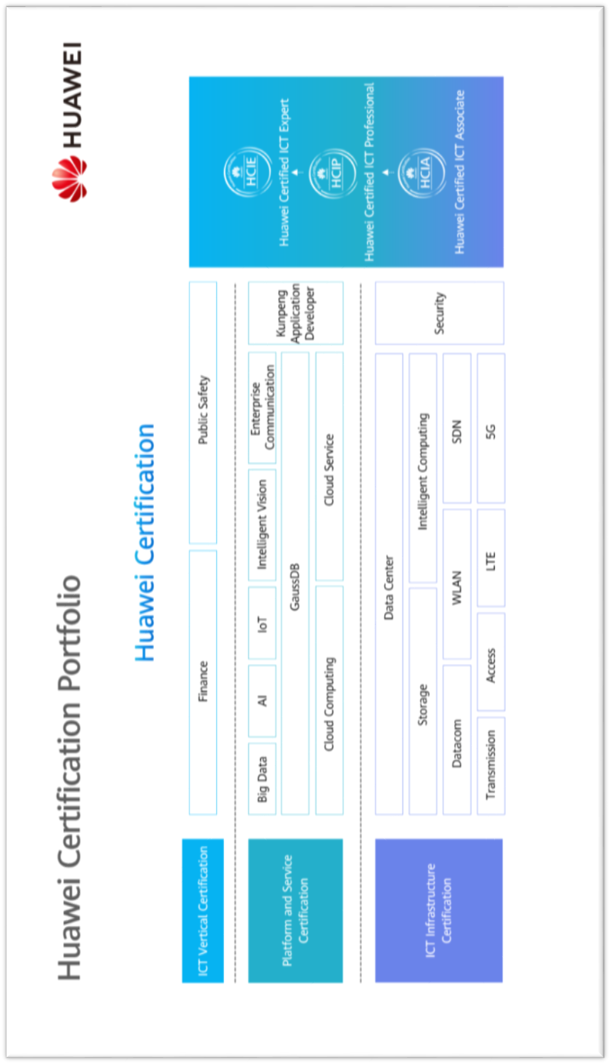

Contents
1 References and Tools 4
1.1 References 4
1.2 Software Tools 4
1.3 Version Description 5
2 Scenario-based Practice of Storage O&M Management 6
2.1 Course Overview 6
2.2 Objectives 6
2.3 Case Background 6
2.4 Tasks 7
2.4.1 Scenario 1: Checking Storage Device Status 7
2.4.2 Scenario 2: Inspecting Storage Devices on SmartKit 13
2.5 Summary and Conclusion 16

References and Tools
The commands and documents listed in this document are for reference only. Use the corresponding commands and documents based on the product version in the actual environment.

References
            - Huawei OceanStor Dorado V6 Product Documentation
You can log in to Huawei's technical support website (https://support.huawei.com/enterprise/) and use the search box to find and download the desired document or tool.
            - Huawei SmartKit Product Documentation
You can log in to Huawei's technical support website (https://support.huawei.com/enterprise/) and use the search box to find and download the desired document or tool.

Software Tools
            - PuTTY
You are advised to use the open-source software PuTTY to log in to a terminal. You can visit its public website (putty.org) to find and download the corresponding document or tool.
            - SmartKit
You can log in to Huawei's technical support website (https://support.huawei.com/enterprise/) and use the search box to find and download the desired document or tool.

Version Description
The recommended platform and software versions in the practice tasks are as follows:
Name | Version | Quantity | Remarks
Huawei storage | Huawei OceanStor Dorado V6 | 1 | None
SmartKit software | SmartKit V2R7C00RC1 | -- | This version or later is recommended.
Windows OS | Windows Server 2012 or Windows Server 2016 | -- | Recommended version
Linux OS | SUSE, Red Hat, CentOS, or EulerOS | -- | Recommended version

Scenario-based Practice of Storage O&M Management

Course Overview
Based on previous studies, this course provides case study and scenario-based practices to help trainees consolidate their prior learning and equip them with storage device O&M management capabilities.

Objectives
- To be able to use DeviceManager to check devices and collect logs.
- To be able to use CLI commands to query basic information about device components and resource pools.
- To be able to use SmartKit to inspect devices and collect logs.

Case Background
Cases in this document are examples only. The actual configurations may vary according to actual environments. For details, see the corresponding product documentation. The names of storage pools and LUNs involved in this document can be customized (for example, LUN _XXX) for different trainees if they use the same device.
An enterprise has completed the acceptance of Project X. It is adding multiple Huawei OceanStor all-flash storage devices (such as Huawei OceanStor Dorado V6) to its data center. The devices have been installed and services have been deployed. Routine maintenance and management are required to ensure the devices are running correctly and the services are stable and reliable.
If you were the administrator in charge of managing and maintaining these devices, how would you perform routine inspections?
The following figure shows the network topology of the enterprise:
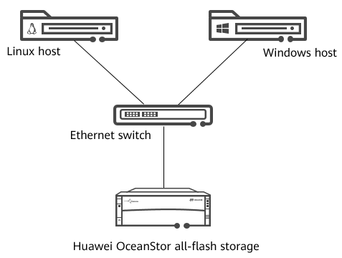
              - Network topology

Tasks

Scenario 1: Checking Storage Device Status
Background
O&M engineers need to periodically inspect storage devices based on a maintenance schedule. For example, they will check whether alarms are being triggered and monitor the resource usage to better understand their running status. This way, if a fault occurs with the storage device, it can be detected and rectified more quickly to ensure service security and reliability.
If you were an engineer, how would you perform the inspection?
Question
What are the routine maintenance items for a storage O&M engineer?
Item | Operation | Daily maintenance item
Item | Operation | Weekly maintenance item
Task 1: Performing O&M Checks on DeviceManager
          - View device details.
Log in to DeviceManager and view storage system information, such as the health status, storage version, and ESN.

[Suggested Procedure]
For details, see Operation and Maintenance > Administrator Guide > Routine Maintenance > Manual Inspection > Checking the Running Status of the Storage Device in the desired product documentation.
          - View alarms.
View the alarm information of a storage system on DeviceManager.

[Suggested Procedure]
For details, see Operation and Maintenance > Administrator Guide > Routine Maintenance > Manual Inspection > Viewing and Handling Alarms in the desired product documentation.
          - Check the status of parts, such as controllers and disks.
On DeviceManager, check the status of controller enclosures, controllers, disks, and ports.
[Suggested Procedure]
For details, see Operation and Maintenance > Administrator Guide > Routine Maintenance > Manual Inspection > Checking the Running Status of the Storage Device > Checking the Storage System Inventory in the desired product documentation.
          - Check the status of BBUs and fan modules.
Use DeviceManager to query the status of parts like BBUs, fan modules, and power modules.

[Suggested Procedure]
For details, see Operation and Maintenance > Administrator Guide > Routine Maintenance > Manual Inspection > Checking the Running Status of the Storage Device > Checking Controller Enclosure BBUs/Checking Fan Modules/Checking Power Modules in the desired product documentation.
          - Check the storage pool status.
On DeviceManager, check the storage pool status and its usage.

[Suggested Procedure]
For details, see Operation and Maintenance > Administrator Guide > Routine Maintenance > Manual Inspection > Checking the Running Status of Services > Checking Storage Pools in the desired product documentation.
          - Check the storage LUN status.
Use DeviceManager to check the LUN usage and status.

[Suggested Procedure]
For details, see Operation and Maintenance > Administrator Guide > Routine Maintenance > Manual Inspection > Checking the Running Status of Services > Checking LUNs in the desired product documentation.
          - Export log files.
Use DeviceManager to export system logs and diagnosis files.
[Suggested Procedure]
For details, see Operation and Maintenance > Administrator Guide > Routine Maintenance > Collecting Storage System Information > Collecting Logs and Alarms Using DeviceManager > Exporting System Data in the desired product documentation.
Task 2: Performing O&M Checks on the CLI
          - Log in to the storage system.
Log in to the storage system using the CLI.

[Suggested Procedure]
For details, see Installation and Upgrade > Initialization Guide > Logging In to the CLI in the desired product documentation.
Note: You can use the IP address of the management network port to log in.
          - Query system information.
Query the storage system information on the CLI.

[Suggested Procedure]
For details, see Reference > Command Reference > Basic Operation Commands > base > show system general in the desired product documentation.
          - Query parts information.
            - Query the disk information on the CLI.
            - Query the controller information on the CLI.
            - Query the fan module information on the CLI.
            - Query the BBU information on the CLI.
[Suggested Procedure]
For details, see:
            - Reference > Command Reference > Hardware Management Commands > disk > show disk general;
            - Reference > Command Reference > Hardware Management Commands > controller > show controller general;
            - Reference > Command Reference > Hardware Management Commands > fan > show fan;
            - Reference > Command Reference > Hardware Management Commands > bbu > show bbu general.
          - Query details about a LUN.
Use the CLI to query LUN information.
[Suggested Procedure]
For details, see Reference > Command Reference > Storage Domain Management Commands > lun > show lun general in the desired product documentation.
          - Query storage pool information.
Use the CLI to query storage pool information.
[Suggested Procedure]
For details, see Reference > Command Reference > Storage Domain Management Commands > storage_pool > show storage_pool general in the desired product documentation.
Task 3: Managing License Files
          - View license information.
View the license information of a storage system on DeviceManager.
[Suggested Procedure]
Log in to the storage system through DeviceManager and check the license of the storage system. Pay attention to the license authorization items, expiration time, and licensed capacity.
For details, see Operation and Maintenance > Administrator Guide > Routine Management > Managing License Files > Viewing an Activated License File in the desired product documentation.
          - Back up the license file.
Query the storage system information on the CLI.
[Suggested Procedure]
For details, see Operation and Maintenance > Administrator Guide > Routine Management > Managing License Files > Backing Up an Activated License File in the desired product documentation.
          - Query license information.
Query license information of the storage system in the CLI.
[Suggested Procedure]
For details, see Reference > Command Reference > License Management Commands > license > show License in the desired product documentation.

Scenario 2: Inspecting Storage Devices on SmartKit
Background
Due to service requirements, a company adjusts its storage devices (for example, migration). O&M engineers need to check the adjusted devices to ensure that the devices are running properly and collect logs to do so. Check items include the device running status, device port status, and disk health status.
If you were one of the engineers, how would you use SmartKit to check storage devices?
Question
What are the typical application scenarios for SmartKit?
Task 1: Performing an Inspection on SmartKit
          - Install the software.
Install SmartKit on the management host. If it has been installed, run it directly.
[Suggested Procedure]
After obtaining the software, double-click the software to start the installation, and install the software as prompted.
          - Run the software.
Run SmartKit.
Note: After the software is started, the system may prompt you to log in. If you have an account, click Authenticate Now and use the account to log in. If you do not have an account, select Authenticate Later.
[Suggested Procedure]
For details, see Operation and Maintenance > Administrator Guide > Common Management Software and Access Method > Logging In to the Storage System O&M Software in the desired product documentation.
          - Add devices.
Add storage devices to be inspected on SmartKit.
[Suggested Procedure]
For details, see Operation and Maintenance > Administrator Guide > Routine Maintenance > Inspection Using SmartKit in the desired product documentation.
          - Inspect devices.
Inspect the newly added devices on SmartKit.
[Suggested Procedure]
For details, see Operation and Maintenance > Administrator Guide > Routine Maintenance > Inspection Using SmartKit in the desired product documentation.
          - Collect logs.
Collect storage device information on SmartKit.
[Suggested Procedure]
For details, see Operation and Maintenance > Administrator Guide > Routine Maintenance > Inspection Using SmartKit in the desired product documentation.
          - (Optional) Check the health of disks.
Analyze disk health on SmartKit.

[Suggested Procedure]
For details, see Operation and Maintenance > Administrator Guide > Routine Maintenance > Inspection Using SmartKit in the desired product documentation.
Note: If the device uses Huawei OceanStor eStor simulator, some information in the analysis report may be incomplete.
Discussion
What information needs to be collected when a fault occurs on a device?
Information Type | Item | Description
Basic information
Fault information
Storage device information
Networking information
Application server information

Summary and Conclusion
My Opinion:
____________________________________________________________________________________________________________________________________________________________________________________________________________________________________________________

