Huawei Storage Certification Training

HCIA-Storage
Scenario-based Practice of Storage Fundamentals

(For Trainees)

HUAWEI TECHNOLOGIES CO., LTD.

Copyright © Huawei Technologies Co., Ltd. 2020. All rights reserved.
No part of this document may be reproduced or transmitted in any form or by any means without prior written consent of Huawei Technologies Co., Ltd.

Trademarks and Permissions
and other Huawei trademarks are trademarks of Huawei Technologies Co., Ltd.
All other trademarks and trade names mentioned in this document are the property of their respective holders.

Notice
The purchased products, services and features are stipulated by the contract made between Huawei and the customer. All or part of the products, services and features described in this document may not be within the purchase scope or the usage scope. Unless otherwise specified in the contract, all statements, information, and recommendations in this document are provided "AS IS" without warranties, guarantees or representations of any kind, either express or implied.
The information in this document is subject to change without notice. Every effort has been made in the preparation of this document to ensure accuracy of the contents, but all statements, information, and recommendations in this document do not constitute a warranty of any kind, express or implied.

Huawei Technologies Co., Ltd.
Address: | Huawei Industrial Base Bantian, Longgang Shenzhen 518129  People's Republic of China
Website: | http://e.huawei.com

Huawei Certification System
Huawei Certification follows the "platform + ecosystem" development strategy, which is a new collaborative architecture of ICT infrastructure based on "Cloud-Pipe-Terminal". Huawei has set up a complete certification system comprising three categories: ICT infrastructure, Platform and Service, and ICT vertical. Huawei's technical certification system is the only one in the industry covering all of these fields.
Huawei offers three levels of certification: Huawei Certified ICT Associate (HCIA), Huawei Certified ICT Professional (HCIP), and Huawei Certified ICT Expert (HCIE).
Huawei Certified ICT Associate-Storage (HCIA-Storage) is designed for Huawei engineers, students and ICT industry personnel. HCIA-Storage covers storage technology trends, basic storage technologies, common advanced storage technologies, business continuity solutions for storage and storage system O&M management.
The HCIA-Storage certificate introduces you to the storage industry and markets, helps you understand sector innovation, and makes sure you stand out among your industry peers.
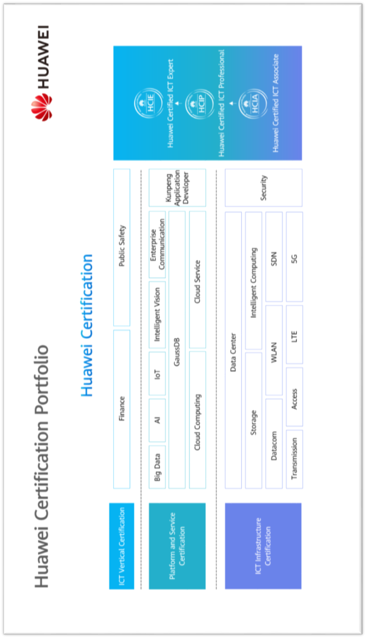

Contents
1 References and Tools 4
1.1 References 4
1.2 Software Tools 4
1.3 Version Description 5
2 Scenario-based Practice of Storage Fundamentals 6
2.1 Course Overview 6
2.2 Objectives 6
2.3 Case Background 6
2.4 Tasks 7
Scenario 1: Requirement Analysis, Planning, and Design 7
Scenario 2: Initial Configuration 10
Scenario 3: Basic Service Planning and Configuration 11
2.5 Summary and Conclusion 17

References and Tools

References
The commands and documents listed in this document are for reference only. Use the corresponding commands and documents based on the product version in the actual environment.
Huawei OceanStor Dorado V6 Product Documentation
Features supported by Huawei OceanStor Dorado vary with product models. For details, see the product documentation of the relevant model. You can log in to Huawei's technical support website (https://support.huawei.com/enterprise/en/index.html) and use the search box to find and download the desired document or tool.

Software Tools
            - Huawei OceanStor UltraPath
You can log in to Huawei's technical support website (https://support.huawei.com/enterprise/en/index.html) and search for UltraPath to find and download the desired document or tool.
            - PuTTY
You are advised to use the open-source software PuTTY to log in to a terminal. You can visit its public website (putty.org) to find and download the desired document or tool.

Version Description
Name | Version | Quantity | Remarks
Storage system | Huawei OceanStor Dorado V6 | 1 | Recommended version
Windows OS | Windows Server 2012 and Windows Server 2016 | - | Recommended version
Linux OS | SUSE, Red Hat, CentOS, and EulerOS | - | Recommended version
S5700 switch | - | 1
Multipathing software | UltraPath 21.6.3 | - | Recommended version

Scenario-based Practice of Storage Fundamentals

Course Overview
This course provides case study and scenario-based practices to help trainees consolidate their knowledge of initial configuration and basic service deployment and implementation of Huawei OceanStor storage.

Objectives
To understand common networking modes for storage services
To plan and design networks
To complete the initial configuration of the storage system
To install UltraPath
To plan and configure block services

Case Background
Cases in this document are examples only. The actual configurations may vary according to actual environments. For details, see the corresponding product documentation.
Company W needs a high-performance storage system to support new service lines. The planned upper-layer services are OLTP transactional databases. To meet service development requirements, Company W purchases a Huawei OceanStor all-flash storage system. To ensure the services run properly, two test servers are used. Server A runs Windows, server B runs Linux, and the storage devices provide block storage services for the two servers over an IP network.
As a storage engineer, you are responsible for network planning and design, initial configuration, and block service configuration of the storage system.

Tasks

Scenario 1: Requirement Analysis, Planning, and Design
Background
As a storage engineer, how do you plan networks?
Question
            - Please analyze the business requirements of Company W.
            - What needs to be done to meet the requirements of Company W? (For example, what needs to be planned?)

[Suggested Procedure]
For details, see Install and Upgrade > Installation Guide > Installation Planning in the desired product documentation.
            - What are the common networking modes for storage service networks? How can you prevent SPOFs?

[Suggested Procedure]
For details, see Install and Upgrade > Installation Guide > Installation Planning in the desired product documentation.
Task 1: Obtaining Device User Information
Plan and record the IP address and user information of the storage device based on the actual lab environment.
Device Name | Management IP Address | Subnet Mask | Gateway | User Name | Password
Storage001
Host001
Host002

[Suggested Procedure]
Follow certain principles when planning the IP address and user information of the storage device.
For details, see Install and Upgrade > Installation Guide > Installation Planning in the desired product documentation.
The following example is for reference only. The actual information may vary depending on lab environment.
Task 2: Designing the Network Topology
Draw the service network topology based on the case background.
Huawei OceanStor all-flash storage | Linux server
Ethernet switch | Windows server

[Suggested Procedure]
For details, see Install and Upgrade > Installation Guide > Installation Planning in the desired product documentation.
[Extension]
To ensure the security and stability of Company W's services, you may use dual-switch networking to build the storage system. Draw the dual-switch networking topology.
Task 3: Planning the Front-End Service Network
Plan the device connections for the front-end service network.
Device Name | Connection Diagram
IP_Switch001
Host001 | 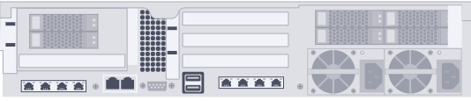
Host002
Storage001 | 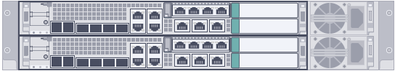

[Suggested Procedure]
For details, see Huawei Storage Networking Assistant (https://support.huawei.com/onlinetoolsweb/sna/#/home).
Task 4: Planning Service IP Addresses
Plan front-end service IP addresses based on the network topology.
Device Name | Port Location | IP Address | Subnet Mask | Gateway
Storage001
Host001
Host002
The following example is for reference only. The actual information may vary depending on lab environment.
[Suggested Procedure]
For details, see Install and Upgrade > Installation Guide > Installation Planning in the desired product documentation.

Scenario 2: Initial Configuration
Background
After the network planning and design are complete, perform initial configuration on the storage system.
Question
What information can be configured in the initial configuration wizard of the Huawei OceanStor all-flash storage system?
Task 1: Initial configuration
After logging in to DeviceManager, perform the initial configuration on the storage system in the initial configuration wizard. This includes configuring basic information, creating a storage pool (excluding scanning for UltraPath hosts and allocating storage resources), and filling in the following form.
The initial configuration address is https://XXX.XXX.XXX.XXX:8088/initialize, where XXX.XXX.XXX.XXX indicates the IP address of the management network port of the storage system.
The following example is for reference only. The actual information may vary depending on lab environment.
Basic Information | Result
Device name
Device location
Device time
Storage pool name, capacity alarm threshold, and capacity exhaustion alarm threshold

[Suggested Procedure]
For details, see Install and Upgrade > Initialization Guide > Logging In and Starting Initialization > Initially Configuring a Storage Device in the desired product documentation.
A license file is a credential for using basic storage features or value-added features. Before practicing, check whether the license file is valid.
In this scenario, a license file has been imported and activated. You can manage the license in the initial configuration wizard.

Scenario 3: Basic Service Planning and Configuration
Background
After the tasks in scenarios 1 and 2 are complete, plan and configure block services.
Question
Plan the storage capacity and answer the following questions.
Storage Pool Name | Disk Type | Disk Quantity | Hot Spare Policy | RAID Policy
StoragePool001
LUN Name | ID | Type | Capacity | /
LUN001
LUN002
            - What factors need to be considered during usable capacity planning?
            - How many RAID levels does Huawei OceanStor Dorado support?
            - Does Huawei OceanStor Dorado support thick LUNs?
[Suggested Procedure]
For details, see Configure > Basic Storage Service Configuration Guide > Planning Basic Storage Services in the desired product documentation.
In this experiment environment, a single storage pool requires at least 8 normal member disks. If a storage pool spans multiple controller enclosures, the minimum number of disks required for creating the storage pool is calculated as follows: Minimum number of disks = 8 x Number of controller enclosures that the storage pool spans.
RAID 2.0+ allows all member disks in a storage pool to provide the hot spare capacity. For ease of understanding, the hot spare capacity is expressed in the number of hot spare disks on DeviceManager.
            - Differences between the nominal capacity of a single disk and the capacity displayed on the OS, hot spare capacity, and RAID usage. The evaluation results of eDesigner take precedence over the considerations of this section.
            - RAID 5, RAID 6, and RAID-TP
            - No
Task 1: Planning Mapping Views
Plan mapping views based on the case background.
Mapping View 1: to Windows Hosts
LUN Name | Owning Storage Pool | LUN Capacity | Host Name | OS | IQN
Mapping View 2: to Linux Hosts
LUN Name | Owning Storage Pool | LUN Capacity | Host Name | OS | IQN
Question
Provide key steps for the block service configuration process.
[Suggested Procedure]
For details, see Configure > Basic Storage Service Configuration Guide > Configuring Basic Storage Services > Configuration Process in the desired product documentation.
Task 2: Configuring Block Services
Based on the case background and planning, configure block services on the Windows and Linux servers. Then, use the storage space on the application server, such as by writing a test file named test.txt to the application server.
          - Create a storage pool.
To ensure that the application server can use the storage system's storage space, create a storage pool named StoragePool001.
During initial configuration, if you have specified that all disks are used to create a unique storage pool, skip this step.
If this step is performed, the capacity of the storage pool depends on the actual planning and experiment environment.
[Suggested Procedure]
For details, see Configure > Basic Storage Service Configuration Guide > Configuring Basic Storage Services > Creating a Storage Pool in the desired product documentation.
          - Create LUNs.
Create LUNs LUN001 and LUN002 and configure their capacities as planned.
[Suggested Procedure]
For details, see Configure > Basic Storage Service Configuration Guide > Configuring Basic Storage Services > Creating a LUN in the desired product documentation.
          - Create hosts.
On DeviceManager, create virtual hosts Host001 and Host002 running Windows and Linux, respectively, for the storage system.
[Suggested Procedure]
For details, see Configure > Basic Storage Service Configuration Guide > Configuring Basic Storage Services > Creating a Host in the desired product documentation.
          - Create mappings.
On DeviceManager, create mappings between the LUNs and hosts.
[Suggested Procedure]
For details, see Configure > Basic Storage Service Configuration Guide > Configuring Basic Storage Services > Creating a Mapping in the desired product documentation.
          - (Optional) Install UltraPath.
OceanStor UltraPath is the multipathing software supported by Huawei. It is installed on servers to control the access of application servers to the storage system. UltraPath selects the paths for application servers to access the storage server and manages the paths.
This step is optional. You are advised to install UltraPath before deploying HyperMetro. If UltraPath is installed and configured after LUNs are mapped to an application server, you must restart the application server for the multipathing policies to take effect.
Install UltraPath on both the Windows and Linux hosts. (Obtain the UltraPath installation package from the trainer.)
[Suggested Procedure]
For details, see Installing UltraPath in the UltraPath user guide of the corresponding OS.
          - Configure connectivity between hosts and the storage system.
            - Establish iSCSI connections.
Establish iSCSI connections between the Windows application server and storage system and between the Linux-based application server and storage system by complying the following configuration logic.
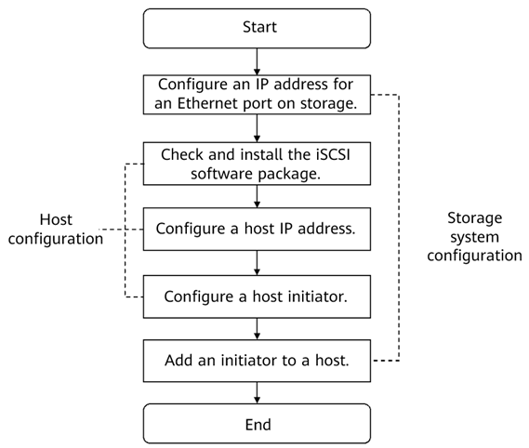

If switches are used, configure zones (for FC connections) or VLANs (for iSCSI connections) by referring to the official product documentation specific to the switch model and version.
The display of DeviceManager varies with different versions.
[Suggested Procedure]
For details, see Configuring Connectivity > Establishing iSCSI Connections in OceanStor Dorado V6 Host Connectivity Guide for XXX, where XXX indicates the OS, such as Windows, SUSE, Red Hat, CentOS, and EulerOS.
            - Scan LUNs on a host.
Scan for disks on the Windows and Linux servers respectively to detect LUNs mapped by the storage system.
[Suggested Procedure]
For details, see Configuring Connectivity > Scanning LUNs on the Host in OceanStor Dorado V6 Host Connectivity Guide for XXX, where XXX indicates the OS, such as Windows, SUSE, Red Hat, CentOS, and EulerOS.
          - Use the storage space on an application server.
            - Manage volumes.
On the Windows and Linux servers, initialize, partition, and format the detected disks so that an application server can use the storage space.
[Suggested Procedure]
For details, see Appendix A Volume Management in OceanStor Dorado V6 Host Connectivity Guide for XXX, where XXX indicates the OS, such as Windows, SUSE, Red Hat, CentOS, and EulerOS.
            - Write a test file to verify the experiment result.
Write a test file to an application server to test whether the application server can properly use the storage space.
[Suggested Procedure]
For details, see Appendix A Volume Management in OceanStor Dorado V6 Host Connectivity Guide for XXX, where XXX indicates the OS, such as Windows, SUSE, Red Hat, CentOS, and EulerOS.
Question
Provide key steps for the service space reclamation process.
[Suggested Procedure]
For details, see Configure > Basic Storage Service Configuration Guide > Managing Basic Storage Services in the desired product documentation.
Task 3: Reclaiming Service Space
          - Disconnect iSCSI connections.
Disconnect iSCSI connections from a service host.
[Suggested Procedure]
For details, see Appendix A Volume Management in OceanStor Dorado V6 Host Connectivity Guide for XXX, where XXX indicates the OS, such as Windows, SUSE, Red Hat, CentOS, and EulerOS.
          - Delete mappings.
Log in to DeviceManager and cancel mappings between the hosts and LUNs.
[Suggested Procedure]
For details, see Configure > Basic Storage Service Configuration Guide > Managing Basic Storage Services > Managing Hosts in the desired product documentation.
          - Delete the hosts and initiators.
Log in to DeviceManager and delete the hosts, initiators, and service IP addresses.
[Suggested Procedure]
For details, see Configure > Basic Storage Service Configuration Guide > Managing Basic Storage Services in the desired product documentation.
          - Delete LUNs.
Log in to DeviceManager and delete the LUNs to release storage space.
[Suggested Procedure]
For details, see Configure > Basic Storage Service Configuration Guide > Managing Basic Storage Services > Managing LUNs in the desired product documentation.
          - Delete the storage pool.
Log in to DeviceManager and delete the storage pool.
[Suggested Procedure]
For details, see Configure > Basic Storage Service Configuration Guide > Managing Basic Storage Services > Managing Storage Pools in the desired product documentation.
          - Verify the result.
Verify that the service space has been reclaimed successfully.

Summary and Conclusion
My Opinion:
____________________________________________________________________________________________________________________________________________________________________________________________________________________________________________________

