Huawei Storage Certification Training

HCIA-Storage
HyperSnap
Scenario-based Practice

(For Trainees)

HUAWEI TECHNOLOGIES CO., LTD.

Copyright © Huawei Technologies Co., Ltd. 2020. All rights reserved.
No part of this document may be reproduced or transmitted in any form or by any means without prior written consent of Huawei Technologies Co., Ltd.

Trademarks and Permissions
and other Huawei trademarks are trademarks of Huawei Technologies Co., Ltd.
All other trademarks and trade names mentioned in this document are the property of their respective holders.

Notice
The purchased products, services and features are stipulated by the contract made between Huawei and the customer. All or part of the products, services and features described in this document may not be within the purchase scope or the usage scope. Unless otherwise specified in the contract, all statements, information, and recommendations in this document are provided "AS IS" without warranties, guarantees or representations of any kind, either express or implied.
The information in this document is subject to change without notice. Every effort has been made in the preparation of this document to ensure accuracy of the contents, but all statements, information, and recommendations in this document do not constitute a warranty of any kind, express or implied.

Huawei Technologies Co., Ltd.
Address: | Huawei Industrial Base Bantian, Longgang Shenzhen 518129  People's Republic of China
Website: | http://e.huawei.com

Huawei Certification System
Huawei Certification follows the "platform + ecosystem" development strategy, which is a new collaborative architecture of ICT infrastructure based on "Cloud-Pipe-Terminal". Huawei has set up a complete certification system comprising three categories: ICT infrastructure, Platform and Service, and ICT vertical. Huawei's technical certification system is the only one in the industry covering all of these fields.
Huawei offers three levels of certification: Huawei Certified ICT Associate (HCIA), Huawei Certified ICT Professional (HCIP), and Huawei Certified ICT Expert (HCIE).
Huawei Certified ICT Associate-Storage (HCIA-Storage) is designed for Huawei engineers, students and ICT industry personnel. HCIA-Storage covers storage technology trends, basic storage technologies, common advanced storage technologies, business continuity solutions for storage and storage system O&M management.
The HCIA-Storage certificate introduces you to the storage industry and markets, helps you understand sector innovation, and makes sure you stand out among your industry peers.
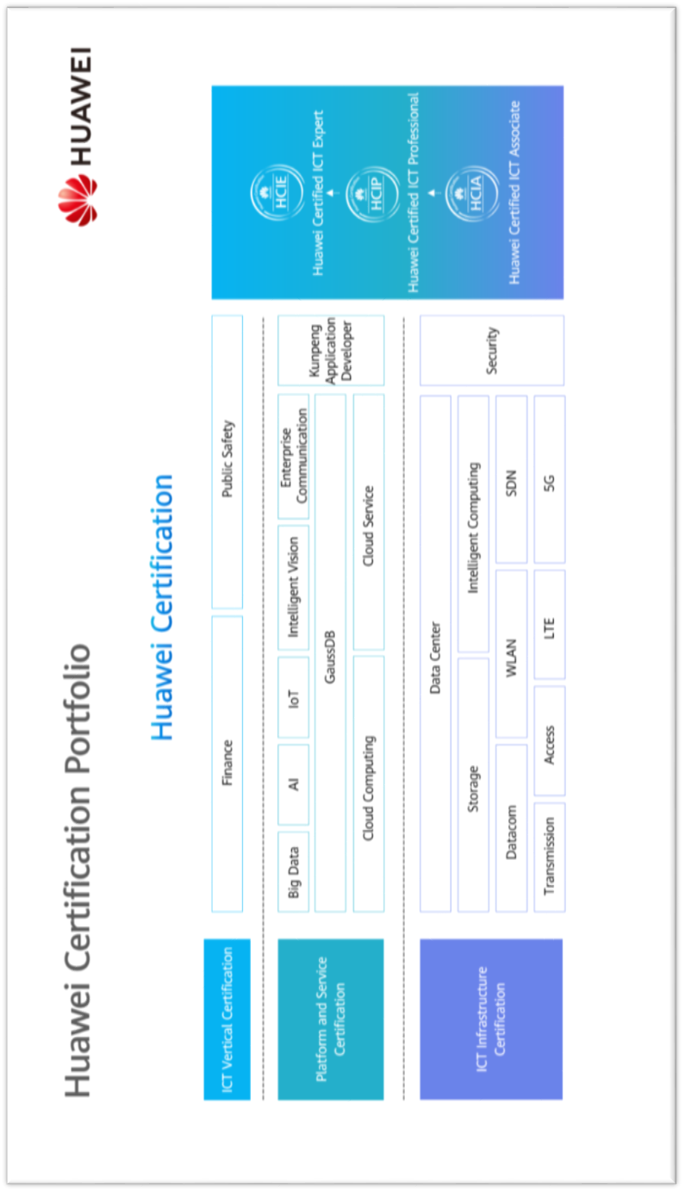
Contents
1 References and Tools 6
1.1 References 6
1.2 Software Tools 6
1.3 Version Description 6
2 Scenario-based Practice on HyperSnap 7
2.1 Course Overview 7
2.2 Objectives 7
2.3 Case Background 7
2.4 Tasks 8
2.4.1 Scenario: Using HyperSnap 8
2.5 Summary and Conclusion 12

References and Tools

References
The commands, documents, and document paths listed in this document are for reference only. The actual commands, documents, and document paths may vary.
Huawei OceanStor Dorado V6 Product Documentation
The specifications of HyperSnap vary by product. For details, see the product documentation of the desired product model. You can log in to Huawei's technical support website (https://support.huawei.com/enterprise/) and use the search box to find and download the desired document or tool.

Software Tools
PuTTY
You are advised to use the open-source software PuTTY to log in to a terminal. You can visit its public website (putty.org) to find and download the desired document or tool.

Version Description
Name | Version | Quantity | Remarks
Storage device | Huawei OceanStor Dorado V6 | 1
Windows OS | Windows Server 2012, Windows Server 2016 | -- | Recommended version
Linux OS | SUSE, Red Hat, CentOS, EulerOS | -- | Recommended version

Scenario-based Practice on HyperSnap

Course Overview
This course provides case study and scenario-based practices to help trainees consolidate their knowledge on the use of HyperSnap. HyperSnap is a common advanced storage technology. Before using HyperSnap, you are advised to learn how to configure basic storage services.

Objectives
- To be able to configure a snapshot of a LUN.
- To be able to roll back data using a snapshot.

Case Background
Cases in this document are examples only. The actual configurations may vary according to actual environments. For details, see the corresponding product documentation. The names of storage pools and LUNs involved in this document can be customized (for example, LUN _XXX) for different trainees if they use the same device.
An enterprise has an OceanStor all-flash storage device. To shorten the backup window, the enterprise purchased HyperSnap.
Help the storage engineers become familiar with operations related to HyperSnap.
The following figure shows the company's live network topology.
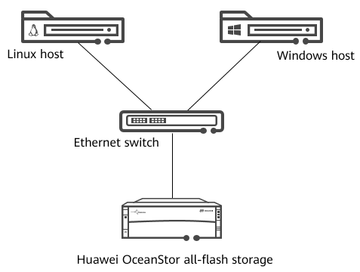
              - Network topology

Tasks

Scenario: Using HyperSnap
Background
A 5 GB LUN named LUN_SOUR has been created and mapped to a host. A file system has been created for LUN_SOUR on the host and has been mounted. Two text files A.txt and B.txt containing characters have been written to LUN_SOUR.
Question
What are COW and ROW?
Task 1: Configuring a Snapshot of a LUN
After a snapshot is created for a source LUN, the snapshot stores that LUN's data as of the time the snapshot was created.
          - Draw a flowchart for configuring HyperSnap.
Demonstrate how to configure HyperSnap.

[Suggested Procedure]
For details about how to draw the flowchart, see Configure > HyperSnap Feature Guide > Configuring and Managing Snapshots of LUNs > Configuring a Snapshot > Flowchart in the product documentation.
          - View HyperSnap license information.
Before configuring HyperSnap, ensure that permission to use HyperSnap has been granted. Help the engineer check the HyperSnap license information.

[Suggested Procedure]
For details about operations on DeviceManager, see Configure > HyperSnap Feature Guide > Configuring and Managing Snapshots of LUNs > Configuring a Snapshot > Checking the License in the product documentation.
For details about operations on the CLI, see Reference > Command Reference > License Management Commands > license > show license in the product documentation.
          - Create a snapshot.
Use LUN_SOUR as the source LUN. Help the engineer create a snapshot named Snap01 for LUN_SOUR and set the rollback rate to Highest.

[Suggested Procedure]
For details about operations on DeviceManager, see Configure > HyperSnap Feature Guide > Configuring and Managing Snapshots of LUNs > Configuring a Snapshot > Creating a Snapshot in the product documentation.
For details about operations on the CLI, see Reference > Command Reference > Data Protect Management Commands > lun_snapshot > create snapshot general in the product documentation.
Question
How can a snapshot of a LUN be used to recover data without saving all copies of the source LUN?
Task 2: Rolling Back Data Using a Snapshot
After configuring the snapshot of the LUN, the engineer mistakenly modifies data on the source LUN. In this case, the engineer needs to roll back data on the source LUN using the snapshot. Modify the files in LUN_SOUR and explain how to roll back the data using the snapshot.
          - Check the snapshot status.
Before the rollback, check whether the snapshot is activated.

[Suggested Procedure]
For details about operations on DeviceManager, see Configure > HyperSnap Feature Guide > Configuring and Managing Snapshots of LUNs > Managing Snapshots of LUNs > Viewing Snapshots in the product documentation.
For details about operations on the CLI, see Reference > Command Reference > Data Protect Management Commands > lun_snapshot > show snapshot available_snapshot in the product documentation.
          - Cancel the mapping between the source LUN and the host.
To ensure data consistency, stop host services before the rollback. Help the engineer cancel the mapping between LUN_SOUR and the host.

[Suggested Procedure]
For details, see Configure > Basic Storage Service Configuration Guide > Managing Basic Storage Services > Managing LUNs > Unmapping a LUN in the product documentation.
          - Start data rollback.
Use Snap01 to roll back data on LUN_SOUR. After the rollback is complete, map LUN_SOUR to the host again, mount the file system, and check whether the data on LUN_SOUR has been rolled back to the time point when the snapshot was activated.

[Suggested Procedure]
For details about operations on DeviceManager, see Configure > HyperSnap Feature Guide > Configuring and Managing Snapshots of LUNs > Managing Snapshots of LUNs > Rolling Back a Snapshot in the product documentation.
For details about operations on the CLI, see Reference > Command Reference > Data Protect Management Commands > lun_snapshot > change snapshot restore in the product documentation.
Question
For a writable snapshot, if data on the snapshot LUN is modified, can the snapshot LUN be used to restore data on the source LUN?
Task 3: Managing Snapshots
After configuring the snapshot and rolling back data using the snapshot, the engineer wants to learn about routine snapshot management operations, such as managing and modifying snapshot properties. Help the engineer become familiar with these operations.
          - Modify the snapshot.
View the snapshot information, change the snapshot name to Snap_Test, and set the rollback rate to Low.

[Suggested Procedure]
For details about operations on DeviceManager, see Configure > HyperSnap Feature Guide > Configuring and Managing Snapshots of LUNs > Managing Snapshots of LUNs > Modifying a Snapshot in the product documentation.
For details about operations on the CLI, see Configure > HyperSnap Feature Guide > Configuring and Managing Snapshots of LUNs > Managing Snapshots of LUNs > Modifying a Snapshot in the product documentation.
          - Delete the snapshot.
After completing the preceding operations, delete the snapshot.

[Suggested Procedure]
For details about operations on DeviceManager, see Configure > HyperSnap Feature Guide > Configuring and Managing Snapshots of LUNs > Managing Snapshots of LUNs > Deleting a Snapshot in the product documentation.
For details about operations on the CLI, see Reference > Command Reference > Data Protect Management Commands > lun_snapshot > delete snapshot in the product documentation.
Discussion
How can the Huawei OceanStor all-flash storage system implement lossless performance using the ROW technology?

Summary and Conclusion
My Opinion:
____________________________________________________________________________________________________________________________________________________________________________________________________________________________________________________

