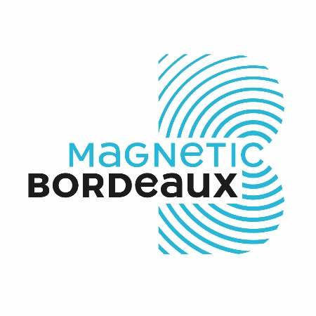

**I. Introduction :**

I hope you will enjoy the charm of this city open to the world. Its successful metamorphosis is continuing in order to engage you in a unique and memorable experience, thanks to an exceptional environment.

Bordeaux is internationally renowned, in particular for its excellence in wine. Yet, Bordeaux reinvents itself, pursuing a dynamic of economic innovation that rises the city to the top 3 of the most attractive french cities.

These various factors make Bordeaux a magnetic metropolitan area.

I invite you to look at some images of our city where it is pleasant to live, as well as to invest in. «  *Wine, work, and smile* !» as summed up a Bordeaux-based entrepreneur.

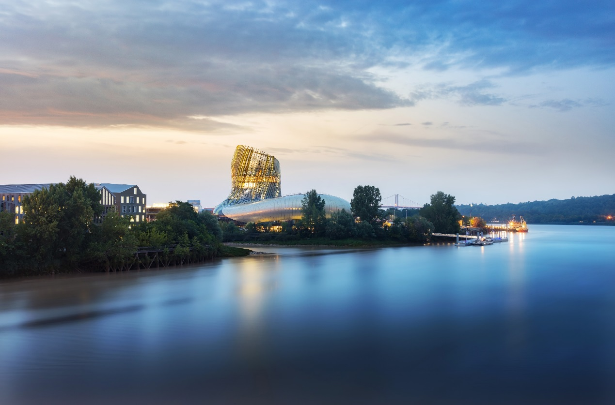

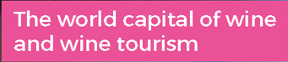

II. **Les atouts du territoire**

Bordeaux Metropole has 761,000 inhabitants, making it the 5th largest metropolitan area in France. It is made up of 28 municipalities located on either side of the Garonne river, 50 km from the Atlantic ocean, and 200km from Spain.

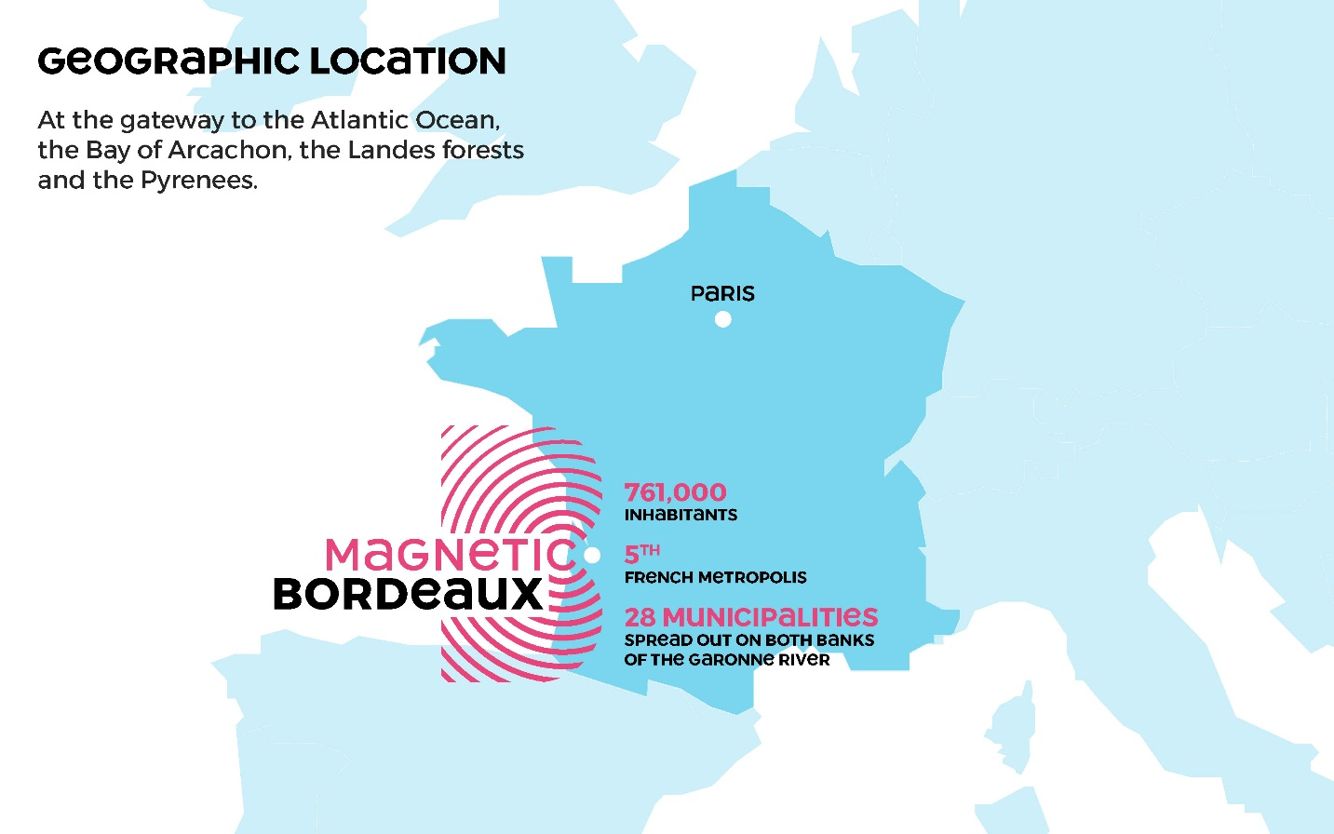

The city boasts an outstanding world heritage with the largest urban ensemble classified by UNESCO on its World Heritage List (1,810 hectares).

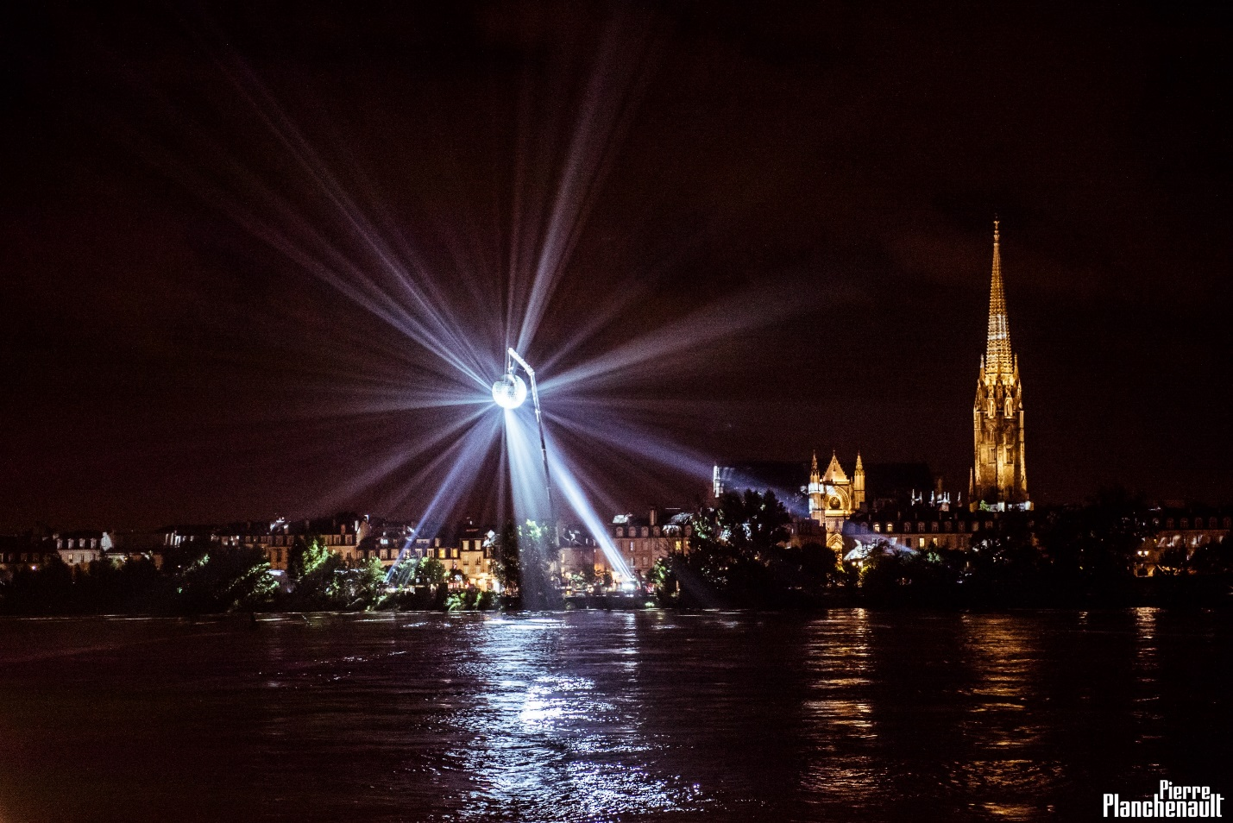

**BORDEAUX, AN INTERNATIONAL DESTINATION**

Largest urban area listed as UNESCO World Heritage

The Bordeaux Metropolitan area is located at the gateway to the Bay of Arcachon, the Landes forest, and the Pyrenees mountains, it includes the most prestigious vineyards in the world: 20 bottles of Bordeaux wine are sold in the world, every second.

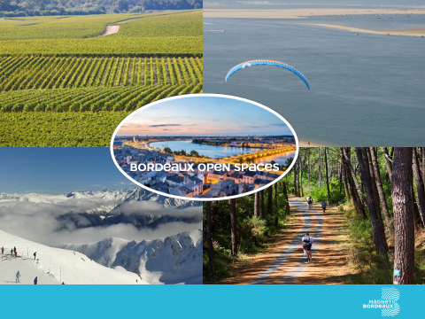

III. **Les infrastructures**

* Slide 7 – Well-connected area

Bordeaux is a well connected area, thanks to :

* **A booming airport**: it reached the 6-million-passengers milestone in 2017. Passenger traffic increased by 7.7% **i**n 2017.
* **High-speed train line (LGV)**: this line puts Bordeaux only 2 hours away from Paris. There are now 2.7 million journeys per year between Bordeaux and Paris. Every day, the TGV high speed train service runs every 30 minutes during peak times.
* **Motorway network**: A 89 to Lyon and Italy; A 63 to Spain; A 10 to Paris; A62 to Toulouse and Mediterranean sea.
* **2nd port on the Atlantic coast** for cruise ship ports.

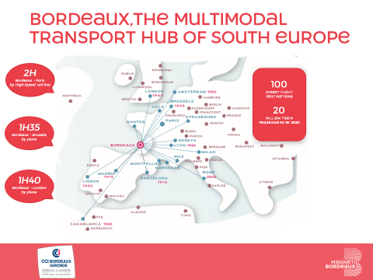

**Thanks to this infrastructure, tourism is developing fast:** in 2017, there were **2.45 million overnight stays in Bordeaux**, a figure that has doubled in 15 years (+10% compared with 2015). **Our area welcomed 7 million tourists last year**.

The Los Angeles Times ranked Bordeaux first in its list of places to visit in the world in 2017, as did Lonely Planet.

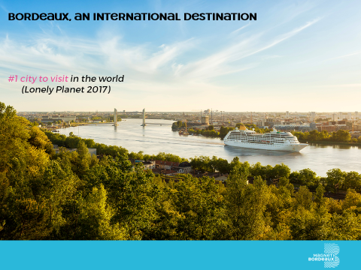

**IV. Les équipements**

The University of Bordeaux has been accredited as part of the national **Initiative d’Excellence** (Idex). It gathers **93,000 students and 10,000 researchers and lecturers**.

Bordeaux university is in the 2016 **Shanghai TOP 200** ranking of Scientific research excellence.

The **most renowned areas** of research are: neurosciences, materials of the future, laser/photonics, cardiology, archaeology, digital and systems certification, environment and climate.

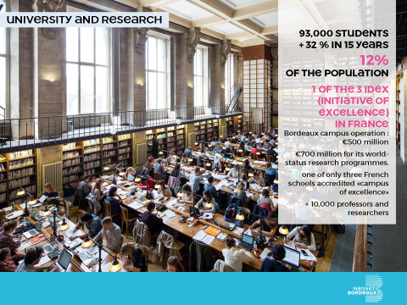

BORDEAUX AÉROPARC (Aeronautics - Space – Defence)

• 2,500 hectares / 400 hectares for development

• Industrial hub

• 40,000 jobs / +10,000 jobs

BORDEAUX INNO CAMPUS (Health / Research / Innovation)

• 1,350 hectares

• 8 hospital sites, university campus

• 48,500 jobs, of which 6,000 highly-skilled jobs

• Ambition: +10,000 jobs

BORDEAUX EURATLANTIQUE (Higher Tertiary Sector - Digital Economy - Greentechs - Creative Economy)

• 740 hectares forming the new southern gateway to Bordeaux

• 50,000 new inhabitants

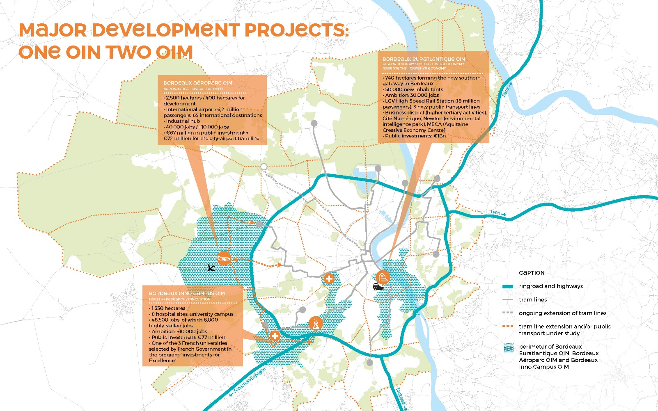Ambition: +30,000 jobs

Among other new amenities as La Cité du Vin, Matmut Stadium, Arena concert hall, the **modernisation of the Exhibition Centre** (delivery 2019) will further improve the attractiveness of Bordeaux as a Congress center (**Bordeaux already ranks #5 in France**).

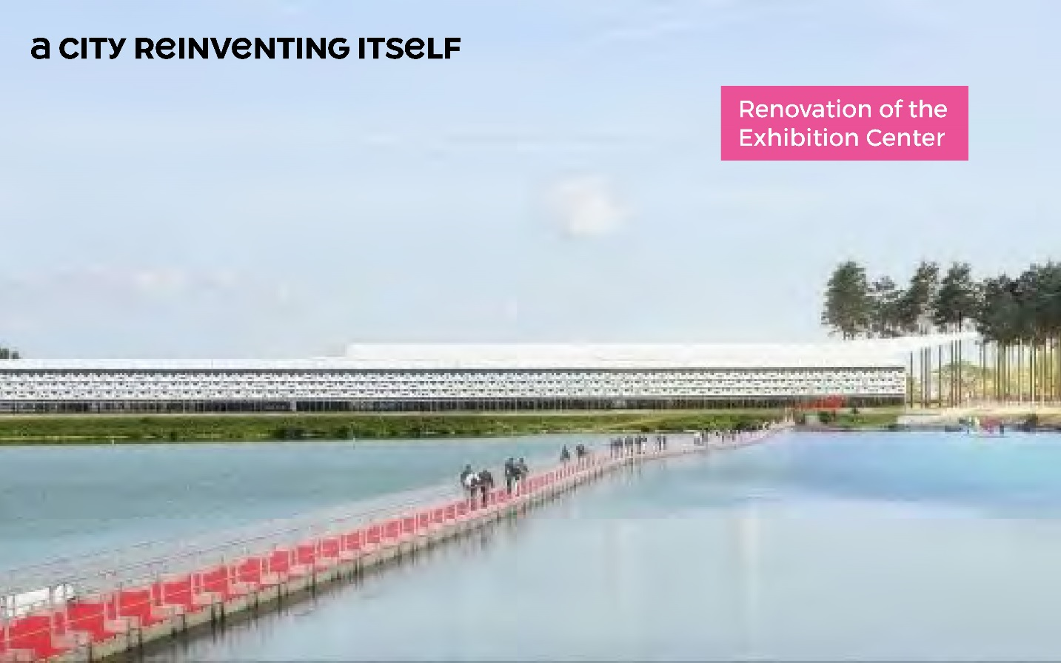

***Bordeaux is used to host major international events****:* Euro 2016 in football, Tall Ships Regatta (2018), or major business events such as (ITS Convention 2015, Mercedes Benz Italy convention 2017), or scientific meetings (European Congress of Neuropathology), and of course **Vinexpo**, the world-famous trade fair for wines and spirits, organised in Bordeaux, Hong Kong, Tokyo and New York.

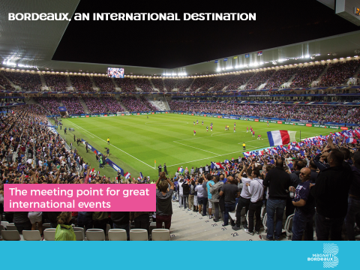

**V. Ecosystème performant et innovant**

Bordeaux enjoys a **business-friendly** environment where everything is done to ensure successful project development, in the metropolitan area, and internationally.

Bordeaux ecosystem is powerful and innovative.

Organized in **competitiveness clusters**, the sectors in which Bordeaux Metropole excels – aeronautics, laser-photonics – make it a key centre in the businesses of the future.

Bordeaux ranks **first**, ahead of Paris, for the **rate of business setup** (17.8%) - according to INSEE 2016 (national institute for statistics and economy) ;

Bordeaux ranks **first**, after Paris, for **innovative business setup** (l’Expansion business magazine, 2017).

***Presence of leading international groups****:* Allianz, Merck (Germany), Agfa Healthcare (Belgium), CGI (Canada), Strycker Corp, IBM, PLY technologies, Steris Surgical Corporation (United States), Barclays, Smurfit (United Kingdom – Ireland) ***and some outstanding local companies with an international outreach****:* FAYAT (1st French independent construction group), CEVA (one of the world’s top 10 groups for veterinary pharmaceuticals), and C-Discount (French leader in cyber-commerce, present in more than 20 countries).

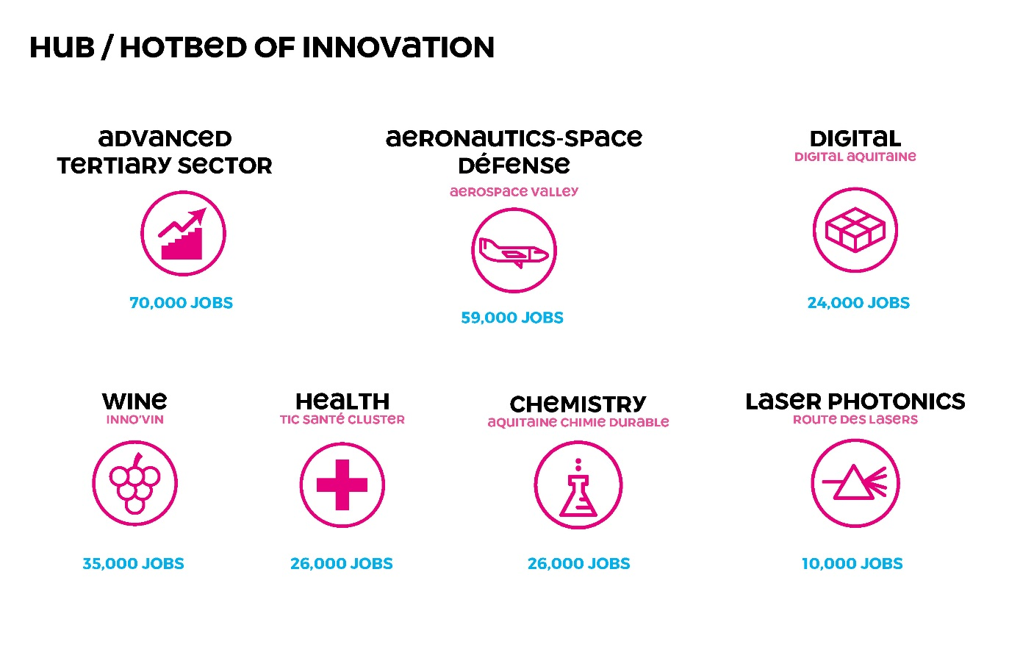

***Areas of excellence in aeronautics, defence and space sectors:***

* **Thales** Air’Innov Campus (€200 million – 58,000 m2)
* **Airbus** Safran Launchers (Ariane 6) (€80 million)
* **Dassault** Falcon Service global maintenance site (€15 million)

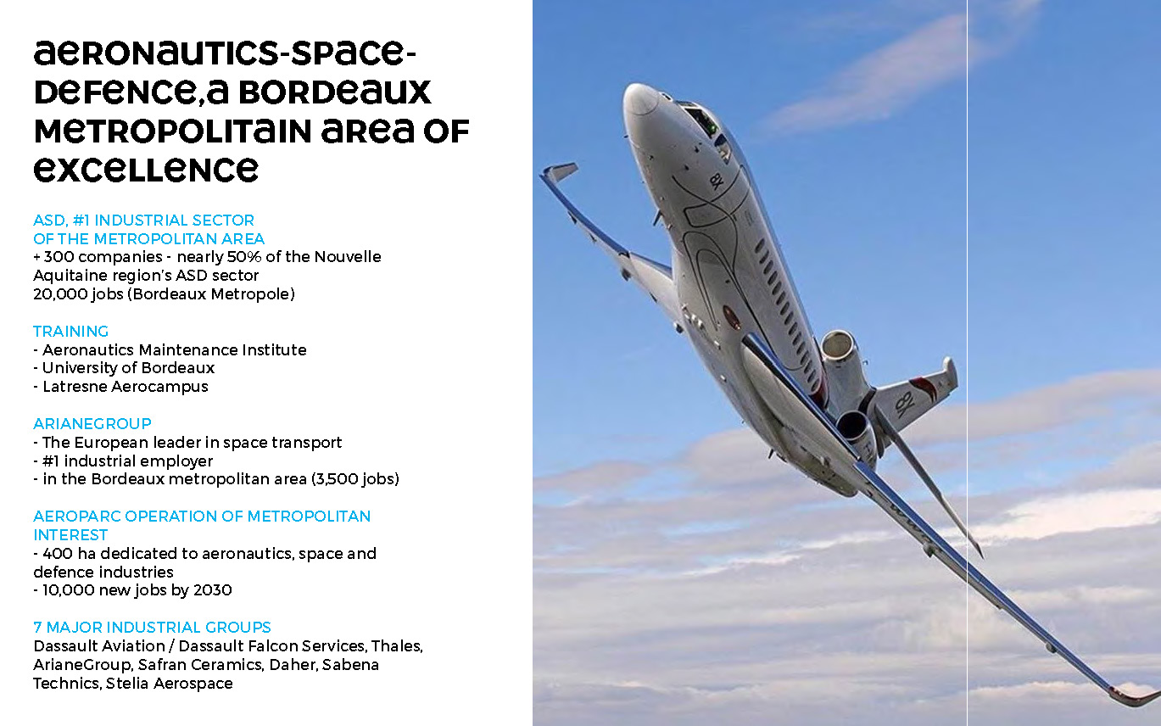

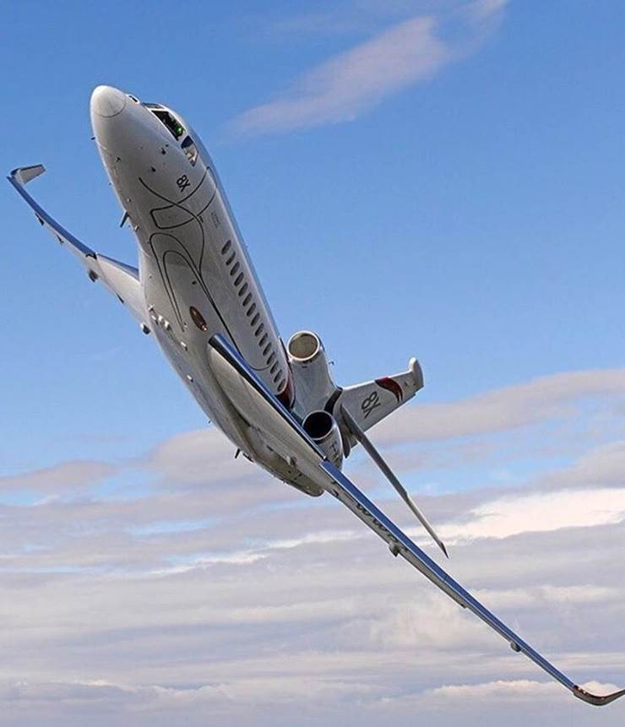

**Digital** represents 23,000 jobs on the territory and keeps on increasing thanks to **outstanding new arrivals** in 2017-2018: **Ubisoft** (ranked 3rd video game publisher worldwide), **OVH** (European cloud leader), **SolidAnim** (the head office of this company specialized in motion capture has left Paris for Bordeaux), **Betclic** (which relocated its headquarters and its London office), **Hermès** (in 2020 will create a leather goods workshop, an investment of several million euros and about 250 new jobs created over four years), **Axa Wealth**, **Deezer**…

The number of investments is increasing. For instance, **fundraising for startups** has raised of +110% last year (2017 / 2016).

The **Digital City** is about to open. It will be the FrenchTech Bordeaux flagship building.

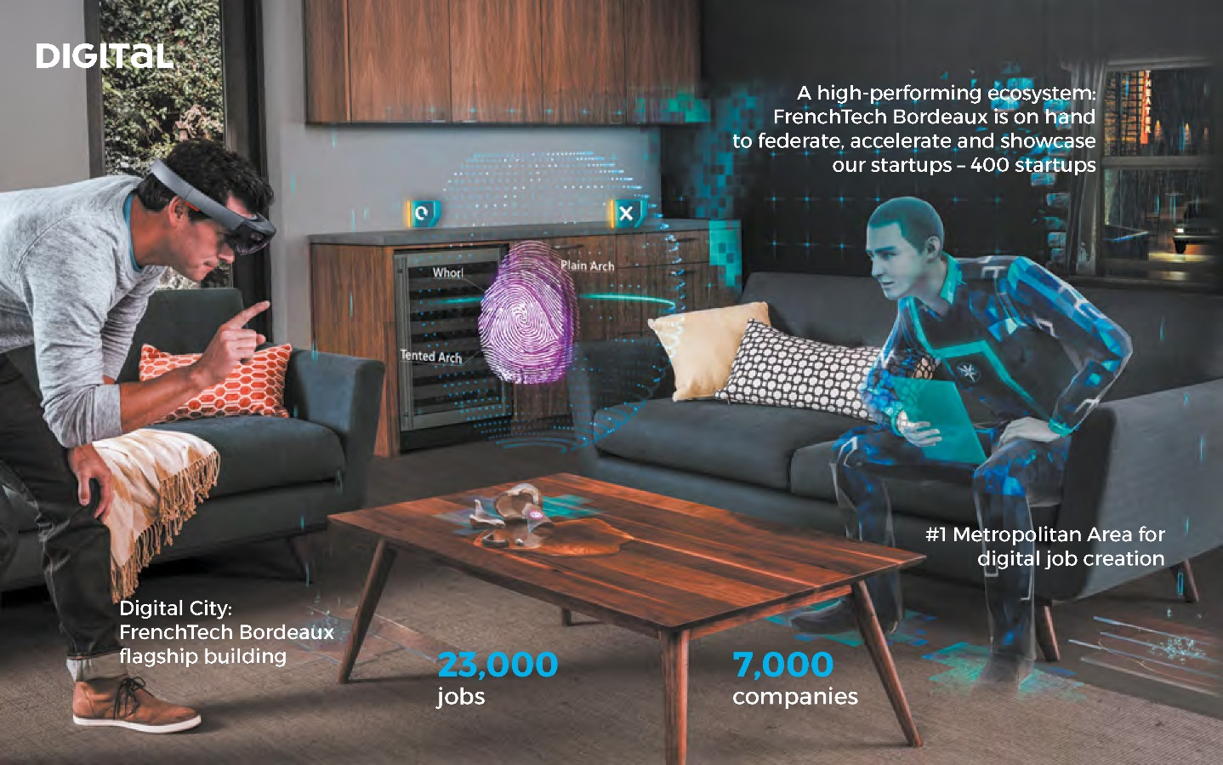

**Creative industries, is one of the most dynamic sectors in Bordeaux area**

#3 French city for the creation of video games

#3 French region for feature film and fiction shooting

For instance, for 2 years now, Bordeaux has hosted the biggest European event on animated film: **Cartoon Movie**. This event is a panorama of the best European animated film production - 900 participants from over 40 countries.

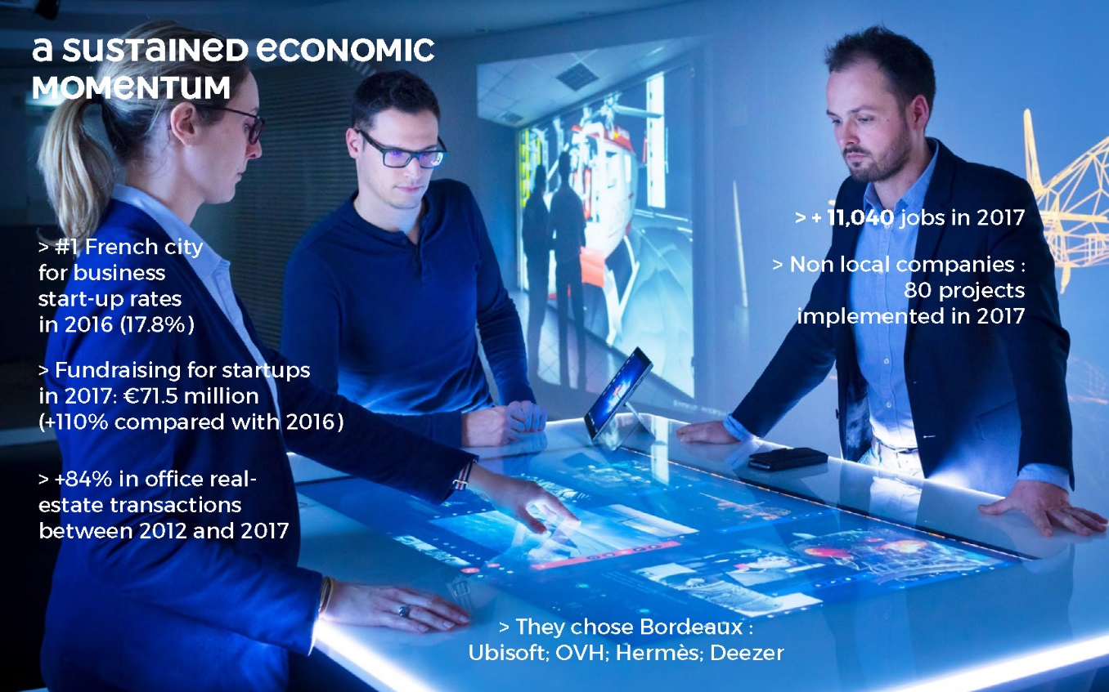

The entrepreneurial ecosystem was enhanced by the French Tech label that Bordeaux Metropole obtained in 2014.

Today FrenchTech Bordeaux gathers 400 startups, 20 incubators-accelerators, focused on key-themes such as healthtech, cyber-commerce, cleantech, fintech…

Over 200 events are dedicated to innovation and entrepreneurship in Bordeaux each year.

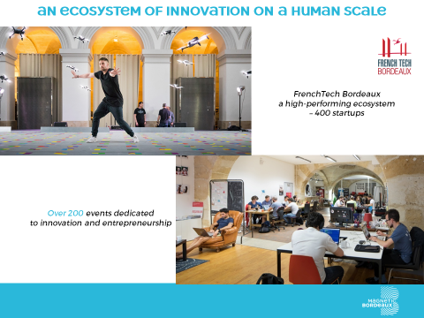

**VI. Qualité de vie**

The power of attraction of Bordeaux metropolitan area owes nothing to chance: the fact that job creation is stronger than elsewhere and that the population is growing faster than the national average (+25% population growth in 20 years : we foresee 1 million inhabitants in 2030) can be explained by the high quality of life enjoyed by people here.

The attractiveness of Bordeaux continues to grow because it has preserved a balance between growth and calm, between professional and personal fulfilment.

Bordeaux ranks #1 French city for its quality of life (PwC 2017)

Bordeaux ranks #6 of the least stressful cities in the world (Zipjet 2017).

Recently, Bordeaux was awarded as the 2nd mid-sized European city in the “human capital and quality of life” category (Financial Times for FDI)

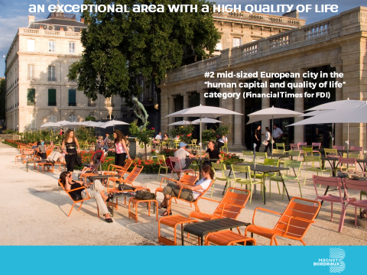

***Concerning the setting up of companies and jobs,*** the Invest in Bordeaux development agency has recorded **a substantial increase**:

* in 2014: net figure of 900 new jobs created,
* in 2017, net figure of 11,000 new jobs created. **11 times more** than in 2014.

For several years, Bordeaux has been chosen by French people as the best place to work (Great Place to Work / Think Tank Institute 2014, 2015, 2016 and 2017)

This year Bordeaux ranked as the most attractive French city, according to Parisian business executives (Cadremploi 2018)

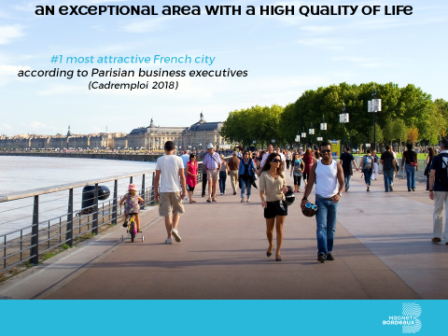

**VII Attractivité**

In March 2018, Bordeaux Metropole was also named by the Financial Times FDI department (Foreign Direct Investment) as No. 1 of the mid-sized European Cities and Regions of the Future 2018/2019– with the best strategy for attracting foreign investment.

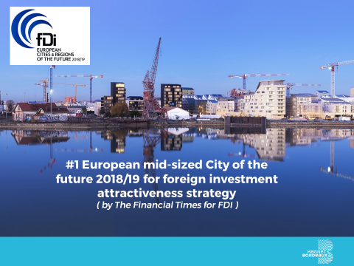

**VIII Conclusion**

Bordeaux already enjoys a high international public profile that gives a significant asset to Bordeaux-based firms going global.

However, we want to continue to innovate, demonstrate our know-how, and enhance Bordeaux attractiveness.

The following are examples of our new initiatives in three various sectors:

* An agreement between French Government and Bordeaux Metropole supporting digital art creation, and cinematographic creation, is currently being prepared ;
* In 2020, Bordeaux Metropole will take on the Presidency of the Community of Ariane Cities, the association which brings together cities and industrial firms working in European space transportation.
* In 2020, Bordeaux will organize RoboCup, the world competition for experts in robotics. It involves assistiv robots for domestic applications, industrial robotics, rescue robots, and soccer-player robots.

This event will highlight local know-how in artificial Intelligence and robotics. By the way, Bordeaux team of soccer-robots is world champion this year… for the third time in a row !

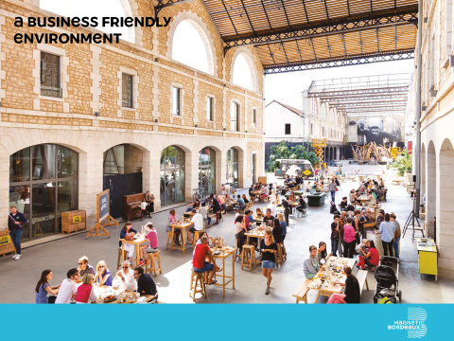

Slide 22 – Palais de la Bourse

As Mary Higgins Clark has written : Bordeaux is a very nice place for creating a nice story.

It’s up to you to write a new page of the story. Bordeaux welcomes you with open arms.

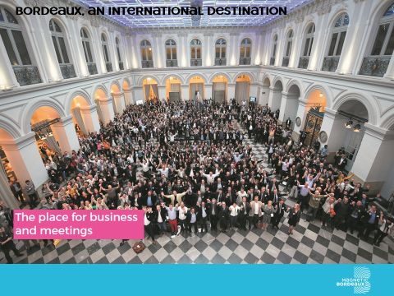

Thank you for your attention.